**SALESIANOS**

**UNIVERSIDAD DON BOSCO**

**FACULTAD DE INGENIERÍA**

**DATAWARE HOUSE Y MINERIA DE DATOS**

**DESAFIO 1**

**CICLO 01-2021**

**GRUPO TEÓRICO**

01

**CARRERA:**

INGENIERÍA EN CIENCIAS DE LA COMPUTACION

**PRESENTADO POR:**

OLMEDO LOPEZ, JONATHAN ALEXIS OL190123

MIRANDA MARTELL, SALVADOR ALEJANDRO MM130477

**CATEDRÁTICO:**

KARENS MEDRANO

**08 DE MARZO DEL 2021**

**SAN SALVADOR, EL SALVADOR, C.A.**

**FUNCIONAMIENTO**

1. El Spa, "Diego", necesita segmentar sus clientes, para realizar una campaña de fidelización, y le pide a usted que efectué un análisis de sus tres sucursales, que defina cuantos grupos y que características tienen. (100%)

Base de datos.

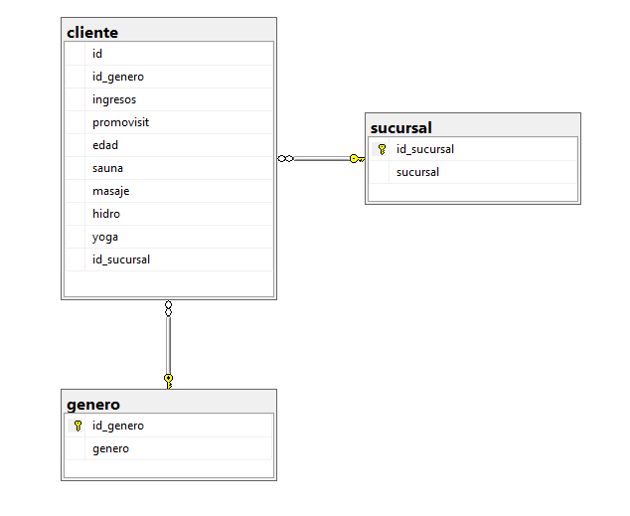

ETL.

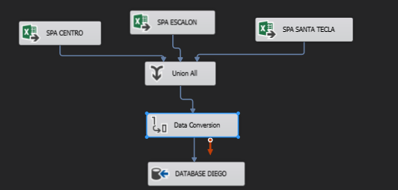

Funcionamiento.

Tabla cliente antes de ser llenada:

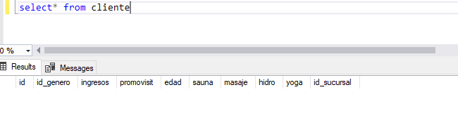

Excel Source, conectado con el Excel base y todos sus campos.

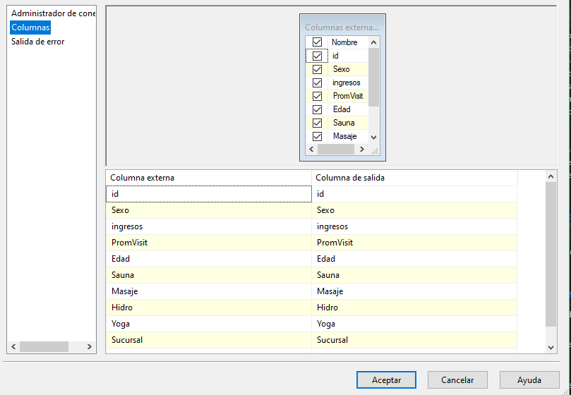

Union all, es donde se unen todo lo campos. Al ser tres diferentes Excel, pero con la misma información y campo fue mucho más fácil la unió de estos.

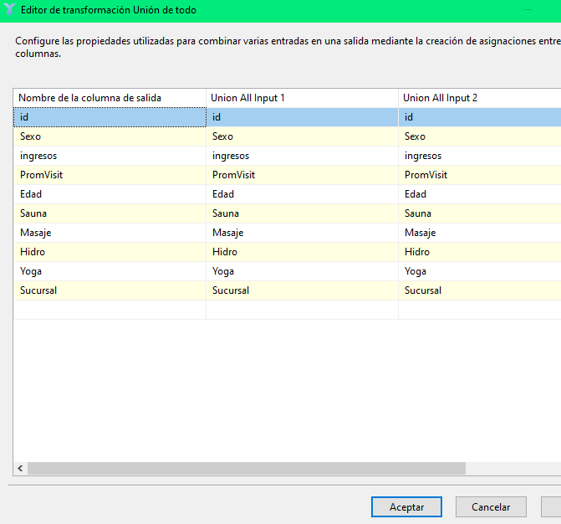

Luego tendríamos el Data conversión, este nos ayuda a darle el mismo tipo de datos de entrada en el Excel, que los que tendremos de salida hacia la base de datos en SQL.

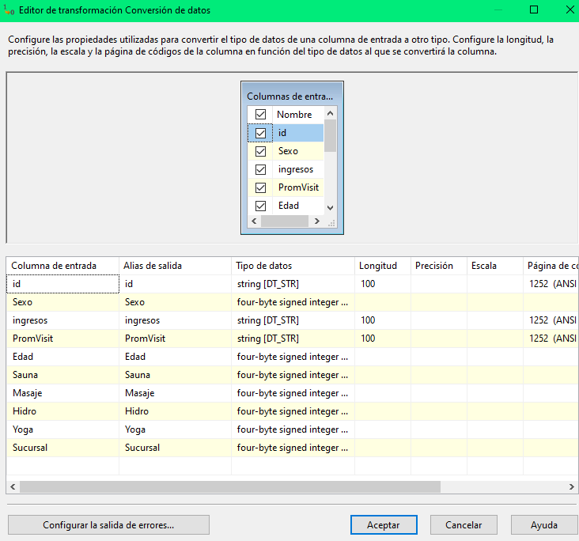

Por último, tendríamos un Destino de ADO NET, este nos hace la conexión directa con Sql para así llenar la base de datos con la información de los Excel.

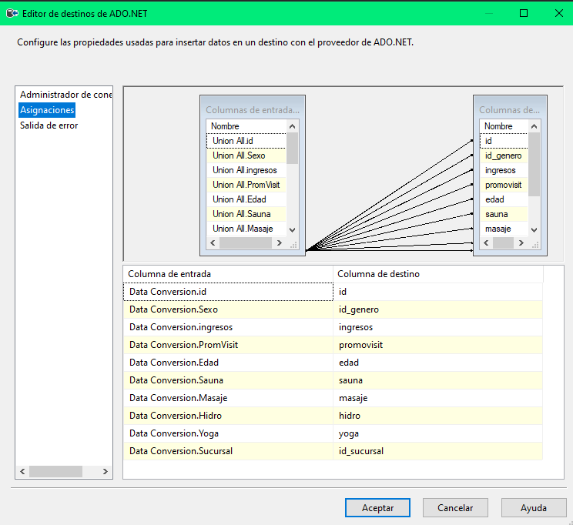

Proceso finalizado.

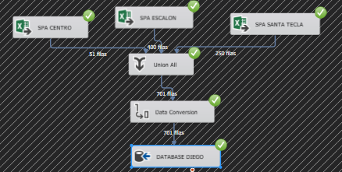

Base de datos llena con la información filtrada.

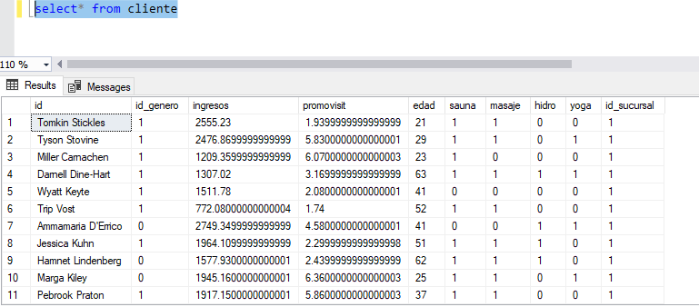

Filtro de información.

* Numero de personas por rango de edad.

select s.sucursal,COUNT(id) as 'Numero de personas mayores de 30 años por sucursal' from cliente c inner join sucursal s on c.id_sucursal = s.id_sucursal where edad > 30 group by s.sucursal

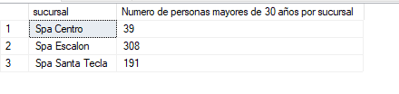

select s.sucursal,COUNT(id) as 'Numero de personas menores de 30 años por sucursal' from cliente c inner join sucursal s on c.id_sucursal = s.id_sucursal where edad < 30 group by s.sucursal

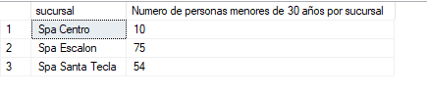

* Cantidad de personas por género.

select g.genero, COUNT(masaje) as 'Cantidad de mujeres que usan los masajes' from cliente c inner join genero g on c.id_genero= g.id_genero where c.id_genero =1 group by g.genero

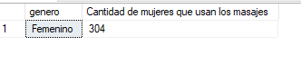

select g.genero, COUNT(sauna) as 'Cantidad de hombres que usan el sauna' from cliente c inner join genero g on c.id_genero= g.id_genero where c.id_genero =0 group by g.genero

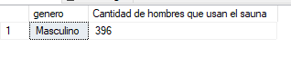

select s.sucursal, COUNT(sauna) as 'Cantidad de hombres que usan el sauna en la sucursal Spa Centro' from cliente c inner join sucursal s on c.id_sucursal = s.id_sucursal where c.id_sucursal = 1 group by s.sucursal

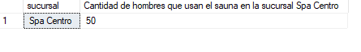

select g.genero, count(c.id_sucursal)'Cantidad de mujeres y hombre en la sucursal Spa Centro' from cliente c inner join genero g on c.id_genero = g.id_genero where c.id_sucursal = 1 group by g.genero

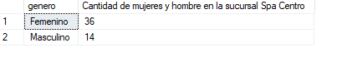

select g.genero, count(c.id_sucursal)'Cantidad de mujeres y hombre en la sucursal Spa Escalon' from cliente c inner join genero g on c.id_genero = g.id_genero where c.id_sucursal = 2 group by g.genero

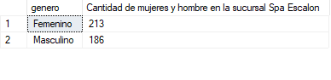

select g.genero, count(c.id_sucursal)'Cantidad de mujeres y hombre en la sucursal Spa Santa Tecla' from cliente c inner join genero g on c.id_genero = g.id_genero where c.id_sucursal = 3 group by g.genero

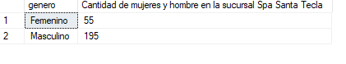

select g.genero, count(c.id_genero) 'Cantidad de mujeres y hombres por las tres sucursales' from cliente c inner join genero g on c.id_genero = g.id_genero group by g.genero

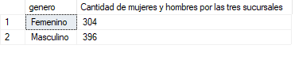

* Cantidad de personas por sucursal o por servicio.

select count(id) as 'Cantidad de clientes que usan el sauna' from cliente where sauna = 1



select s.sucursal,count(id) as 'Cantidad de personas con más de 10 visitas por sucursal' from cliente c inner join sucursal s on c.id_sucursal = s.id_sucursal where promovisit > '10' group by s.sucursal

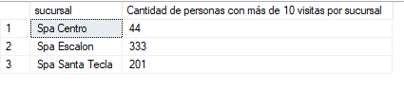

select s.sucursal,count(id) as 'Cantidad de personas con menos de 10 visitas por sucursal' from cliente c inner join sucursal s on c.id_sucursal = s.id_sucursal where promovisit < '10' group by s.sucursal

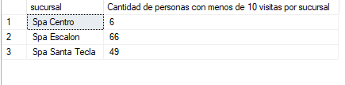

1. La Floristería "Fiorella" quiere saber cómo se compran sus productos, y tiene la data de tres departamentos del país, por lo cual les pide su opinión sobre qué productos sobresalen, que combinaciones son mejores y quieren este estudio por departamento y también por país. (100%)

Primero se realizó la importación de los datos de las ventas contenidos en los 3 archivos de Excel de cada una de las sucursales para tener su tabla propia en una base de datos SQL.

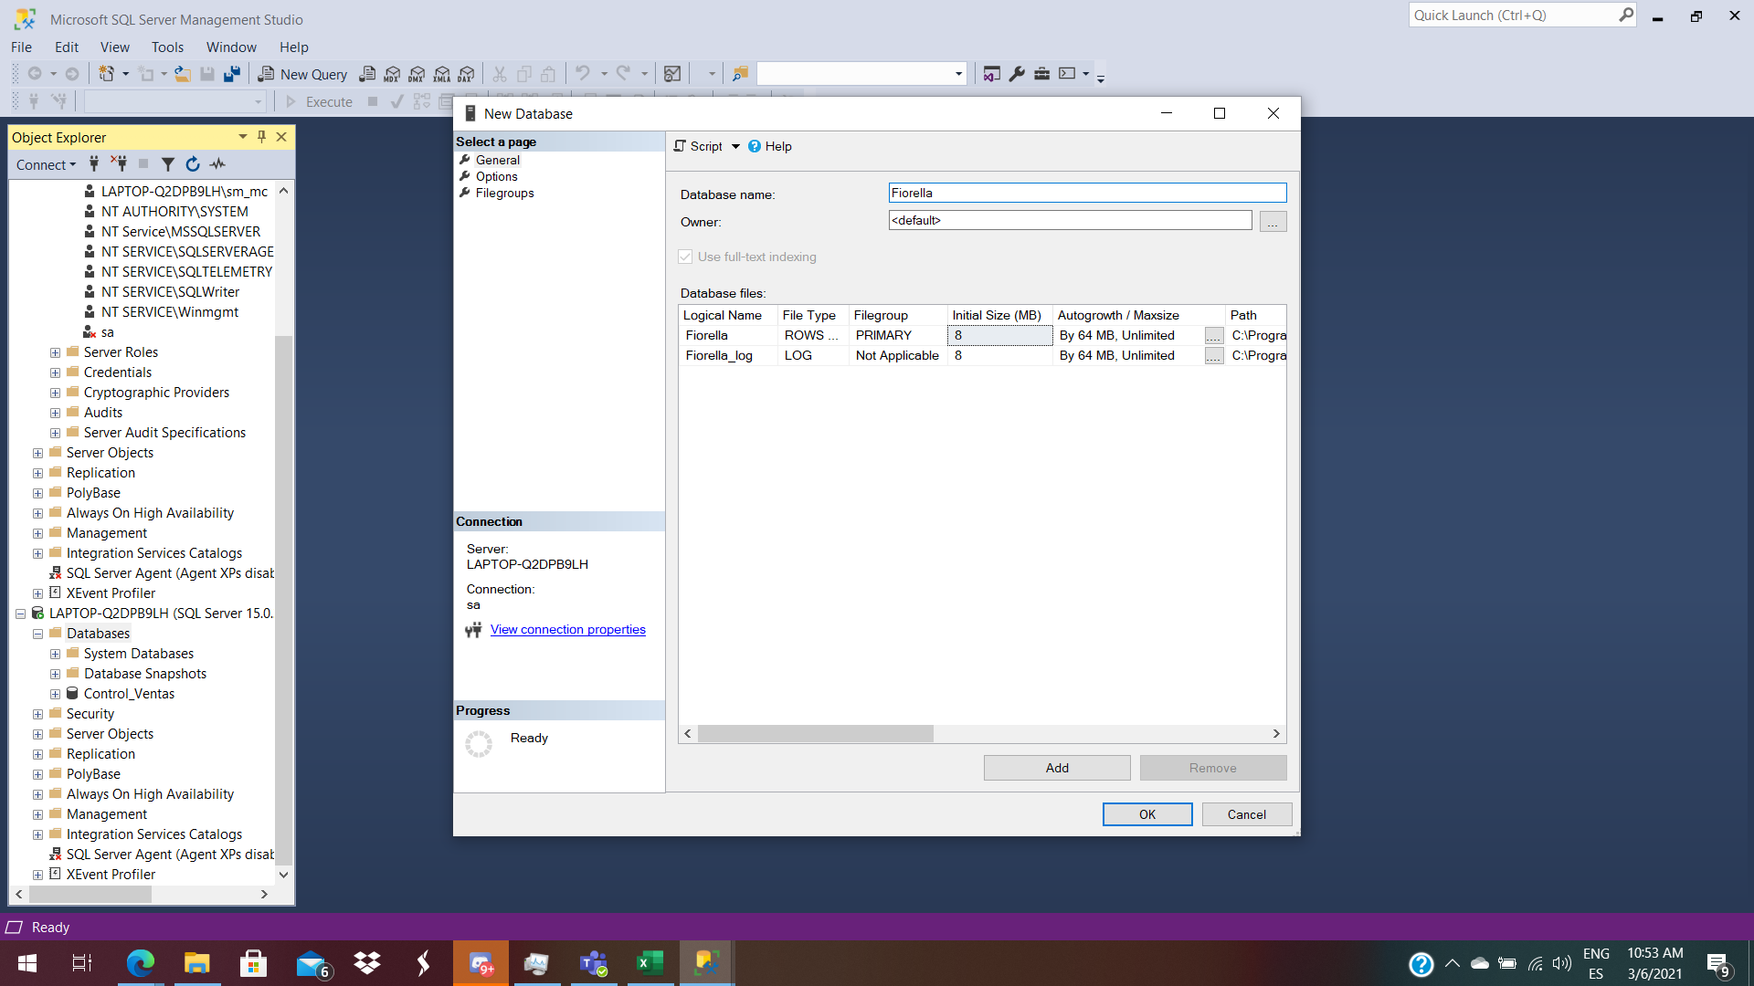

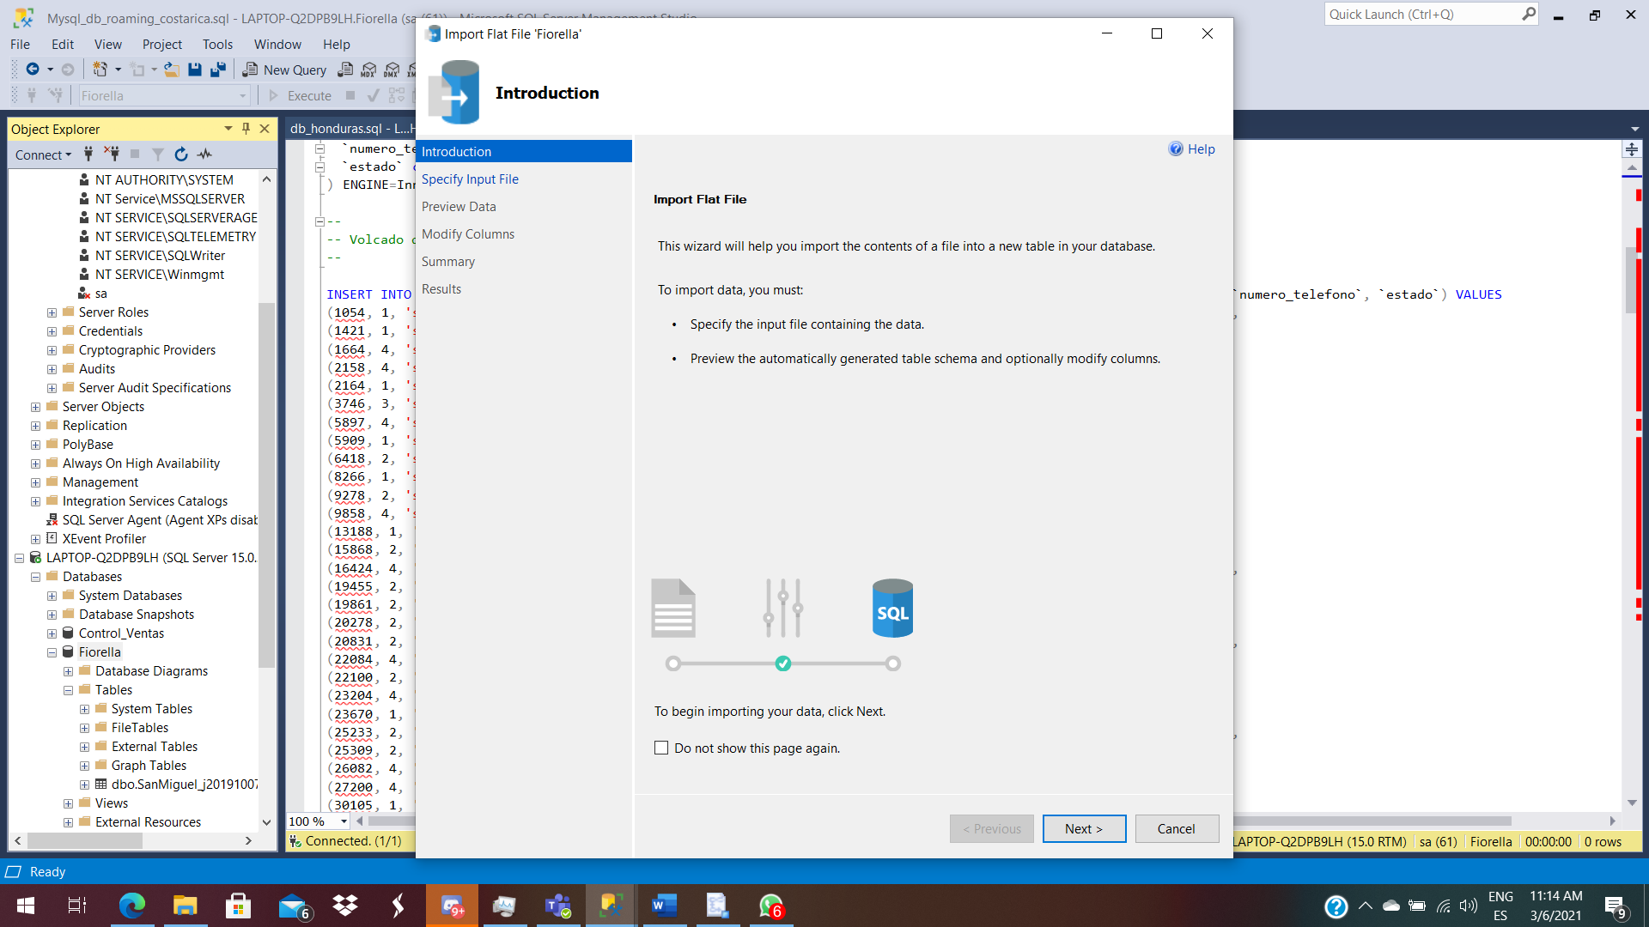

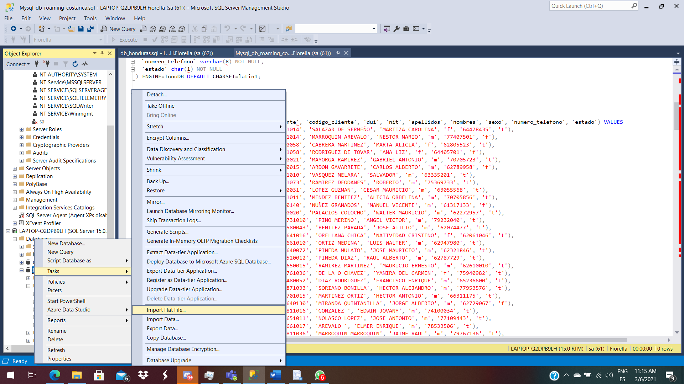

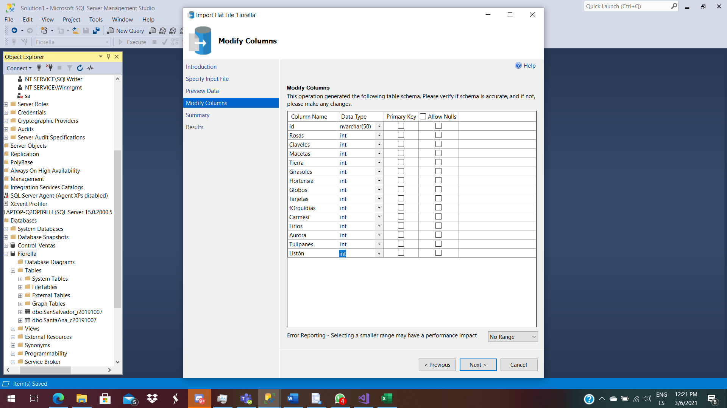

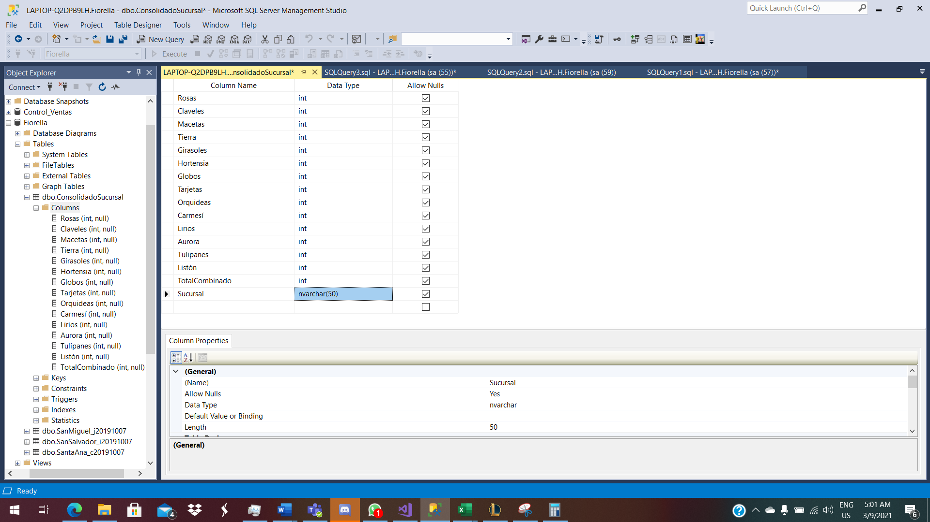

Ya una vez importados los datos de Excel en SQL, se procede a la creación del ETL para el manejo de la información requerida por la Floristería Fiorella. Se utilizan 3 OLE Data Source que se configuran con conexión a la base de datos que contiene las 3 tablas con los datos de las sucursales.

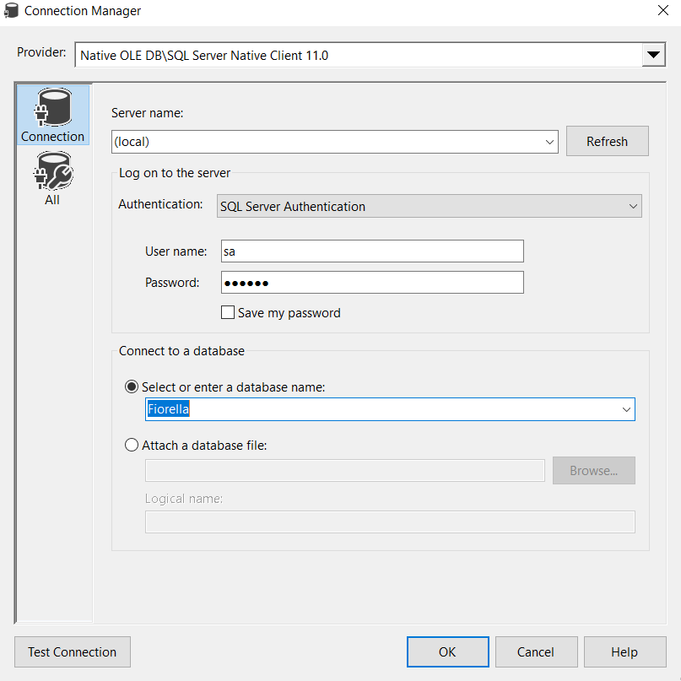

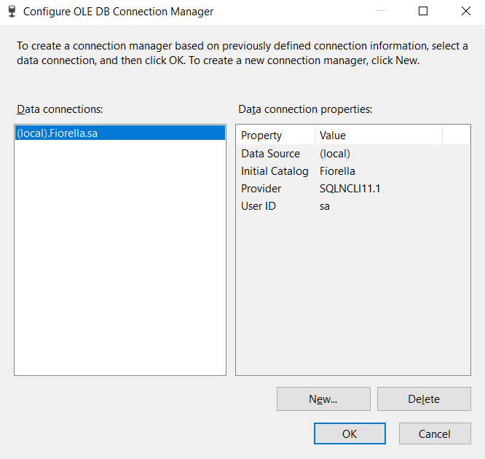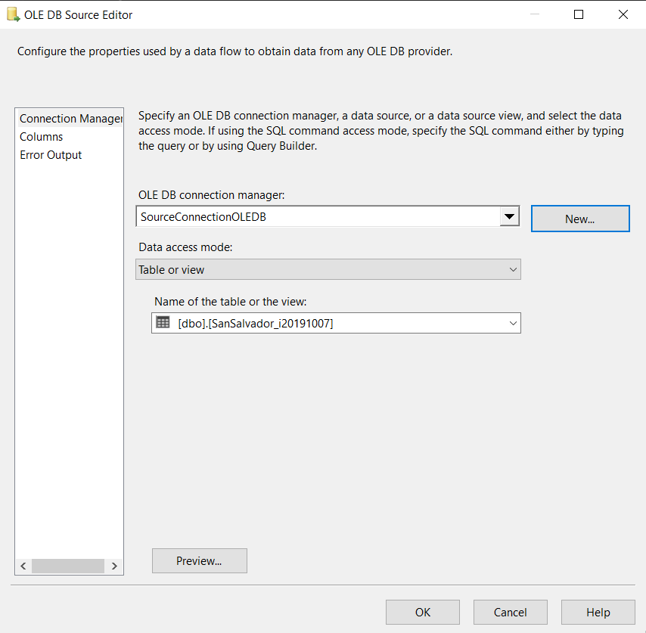

Una vez configurados de manera individual cada data Source, se necesita agregar 2 columnas derivadas. Una columna servirá para el recuento de cuantos productos se compraron en cada venta y la otra para poder saber de qué sucursal es cada dato que se ingresará a la base de datos principal.

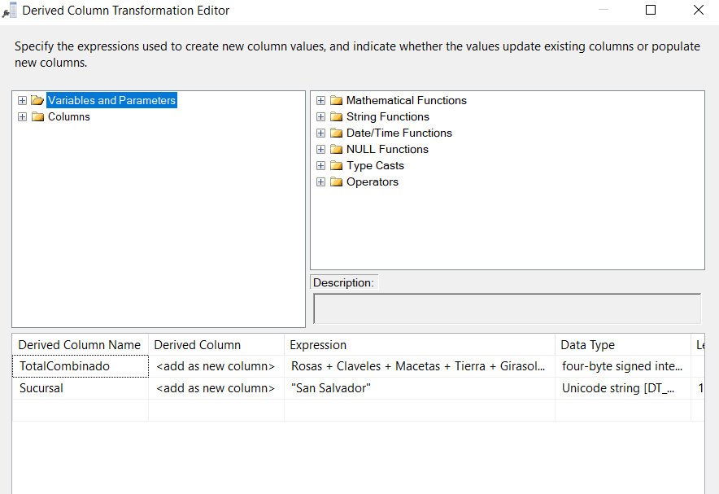

Ya con las 2 columnas derivadas creadas, se puede proceder a la unión de las tres tablas por medio de un Union All para obtener una salida que incluya todos los datos en una sola tabla que tendrá la distinción de cada sucursal y los productos vendidos por transacción.

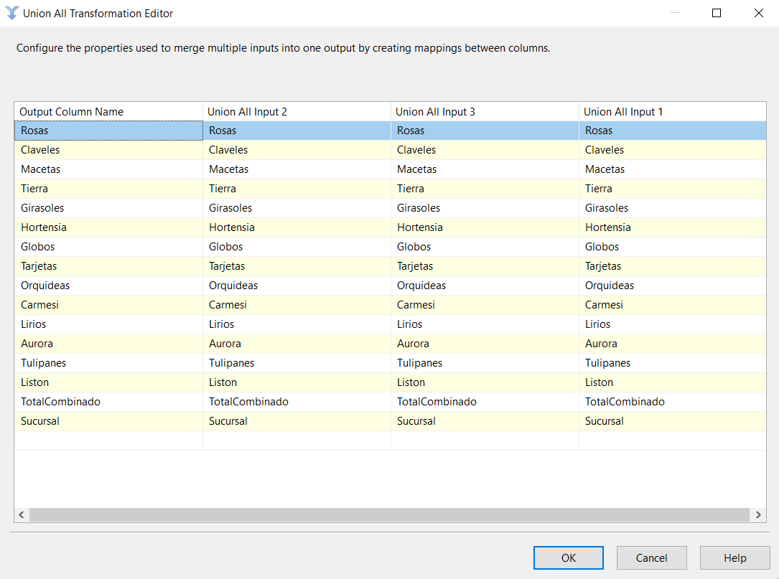

Estos datos consolidados, se envían luego a una tabla que pueda contener todos estos datos ya consolidados y así poder proceder a su análisis. Esto por medio de un ADO.NET Destination Editor.

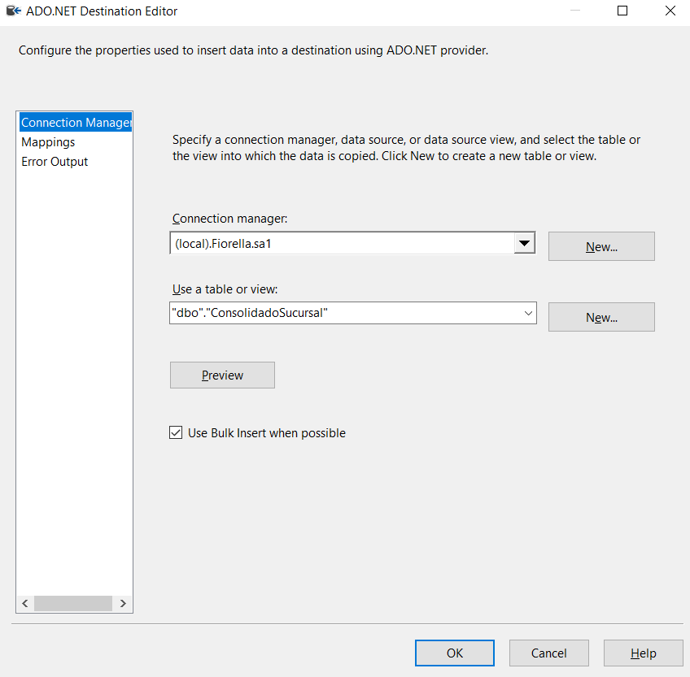

**ETL**

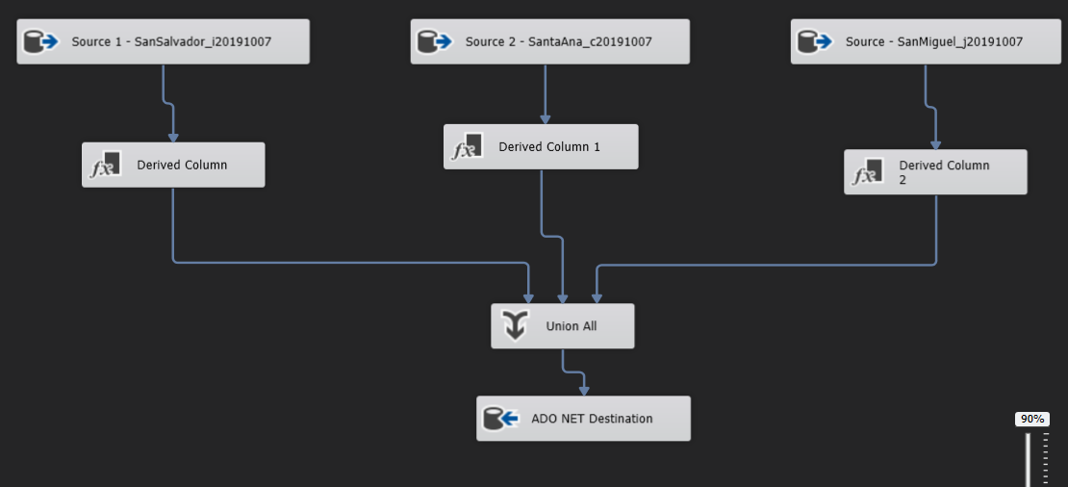

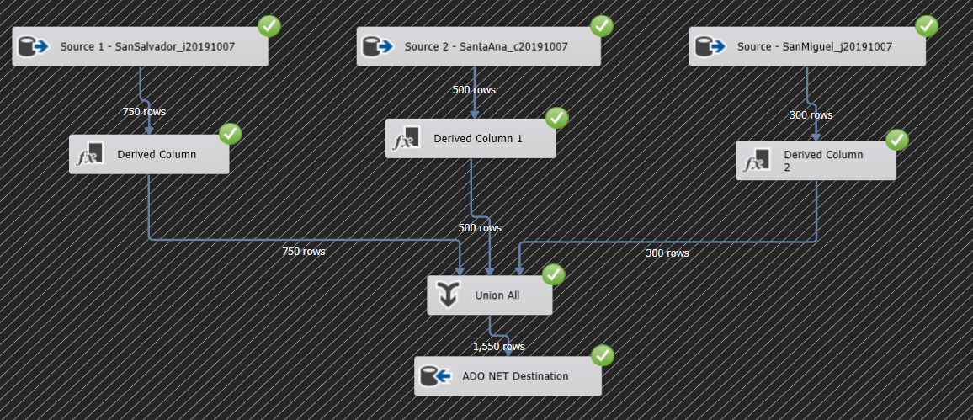

Ya con toda la información consolidada en un solo lugar, se procede a hacer el análisis para encontrar los mejores productos y combinaciones por departamento y a nivel nacional. Para ello, se delimitan estas combinaciones gracias a la columna que recuenta el total de productos por venta y se promedian para ver de cuantos productos suele ser su combinación más popular.

SELECT AVG(TotalCombinado) as 'Promedio Productos San Salvador' from [Fiorella].[dbo].[ConsolidadoSucursal] WHERE Sucursal = 'San Salvador'

SELECT AVG(TotalCombinado) as 'Promedio Productos San Miguel' from [Fiorella].[dbo].[ConsolidadoSucursal] WHERE Sucursal = 'San Miguel'

SELECT AVG(TotalCombinado) as 'Promedio Productos Santa Ana' from [Fiorella].[dbo].[ConsolidadoSucursal] WHERE Sucursal = 'Santa Ana'

SELECT AVG(TotalCombinado) as 'Promedio Productos Nacional' from [Fiorella].[dbo].[ConsolidadoSucursal]

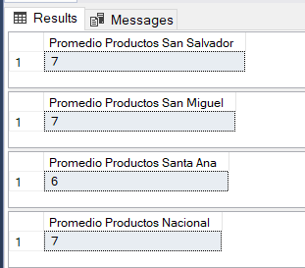

Con estos datos, se sabe que lo más común es combinar hasta 7 productos, a excepción de Santa Ana donde las compras suelen contener un promedio de 6 productos distintos. Luego, se hacen múltiples consultas para saber cuáles son los productos más populares que se compran en combinación con otros y se busca el promedio más alto para la cantidad de productos combinados con cada uno para delimitar cuáles son los 6 más populares para combinar.

San Miguel

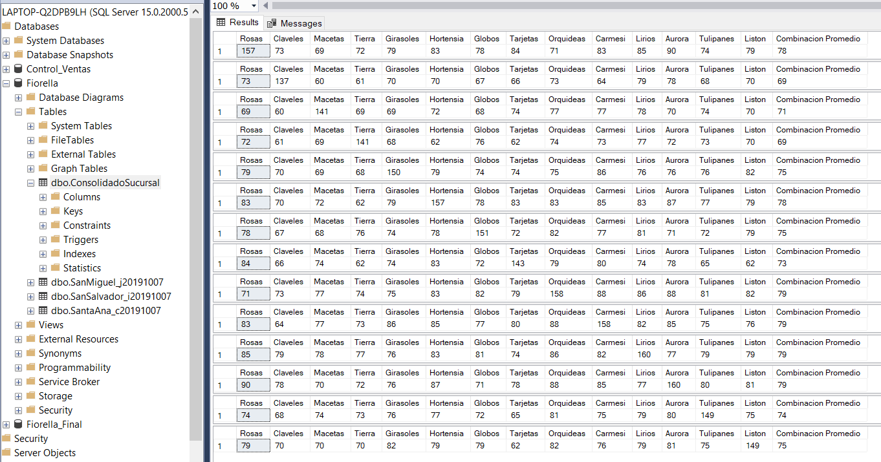

Con San Miguel nos encontramos que se suele combinar hasta 7 productos en promedio, y los 7 productos que más se han comprado junto a otros han sido Rosas (157 junto a otros, en promedio 78 items combinados en total), Hortensias (157, con 78 combinados en promedio), orquídeas (158, con 79 de promedio de otros ítems), Carmesí (158 con 79 de promedio de otros item), Lirios (160 con 79 combinados), Aurora (160 con 79 combinados) y Globos (151 con 75 de promedio combinado), por lo que estos 7 productos combinados vienen a ser la mejor opción de venta combinada.

San Salvador

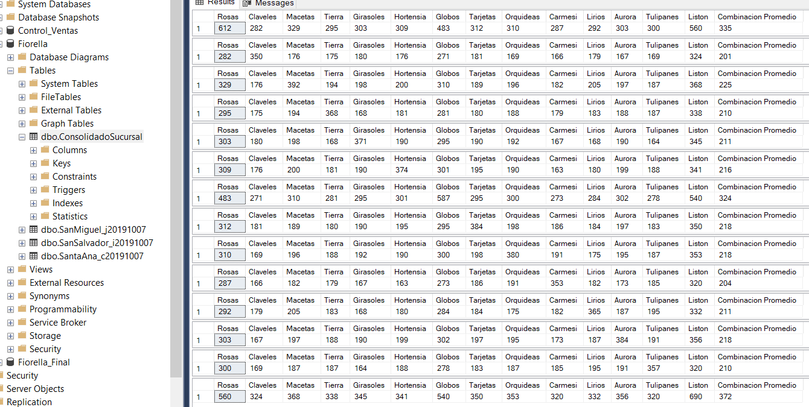

Con San Salvador nos encontramos que se suele combinar hasta 7 productos en promedio, y los 7 productos que más se han comprado junto a otros han sido Rosas (612 junto a otros, en promedio 335 items combinados en total), Globos (587, con 324 combinados en promedio), Listón (690, con 372 de promedio de otros ítems). Estos 3 productos sobresalen por mucho en la combinación con otras ventas ya que los siguientes productos suelen tener máximo 225 de promedio de combinación con otros productos y ninguno se ha vendido más de 400 veces, por lo que para encontrar los otros 4 productos para mejor combinación, es mejor tomar de referencia los top 7 de la consulta de productos vendidos junto al producto más popular, el Listón, esta combinación sería: listón, rosas, globos, macetas, auroras, orquídeas y tarjetas. Siendo la clave del éxito en San Salvador el listón, rosas, globos y 4 productos de preferencia del cliente.

Santa Ana

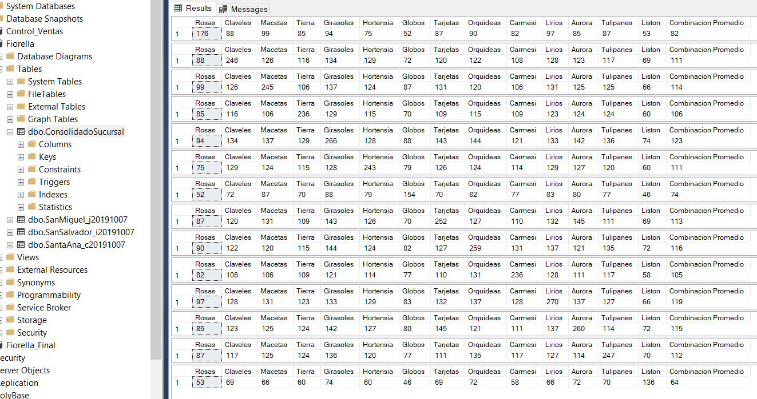

Con Santa Ana nos encontramos que se suele combinar hasta 6 productos en promedio, y los 6 productos que más se han comprado junto a otros han sido Girasoles (266 junto a otros, en promedio 123 items combinados en total), Lirios (270, con 119 combinados en promedio), orquídeas (259, con 116 de promedio de otros ítems), Aurora (260 con 115 de promedio de otros item), Macetas (245 con 114 combinados) y Tarjetas (252 con 113 combinados), por lo que estos 6 productos combinados vienen a ser la mejor opción de venta combinada al ser los más vendidos y los que más se combinan, siendo los Claveles, Tulipanes y Tarjetas la mejor opción como venta adicional siendo 3 item bastante cercanos al resto.

Nivel Nacional

Un análisis a nivel nacional nos puede servir para encontrar una manera general de ofrecer los productos de Fiorella en el caso se quiera abrir una cuarta sucursal, así se puede ir con ofertas más generales en vez de ir por las específicas que funcionan para ciertos departamentos específicamente.

A nivel nacional nos encontramos que se suele combinar hasta 7 productos en promedio, y los 7 productos que más se han comprado junto a otros han sido Listón (975 junto a otros, en promedio 512 items combinados en total), Rosas (945, con 496 combinados en promedio), Globos (892, con 473 de promedio de otros ítems), Aurora (804, con 414 de combinación promedio), Orquídeas (797 total, 415 promedio de otros), y luego un triple empate que provoca que los otros 2 productos se puedan rotar entre Macetas (778 total, 410 promedio de otros), Girasoles (787, con 410 de promedio de otros) y Lirios (795, con 410 de combinación de otros). Los primeros 5 productos más 2 productos adicionales a escoger entre Macetas, Girasoles y Lirios son las apuestas más seguras para el éxito en el caso se busque una expansión a departamentos sin presencia de Fiorella

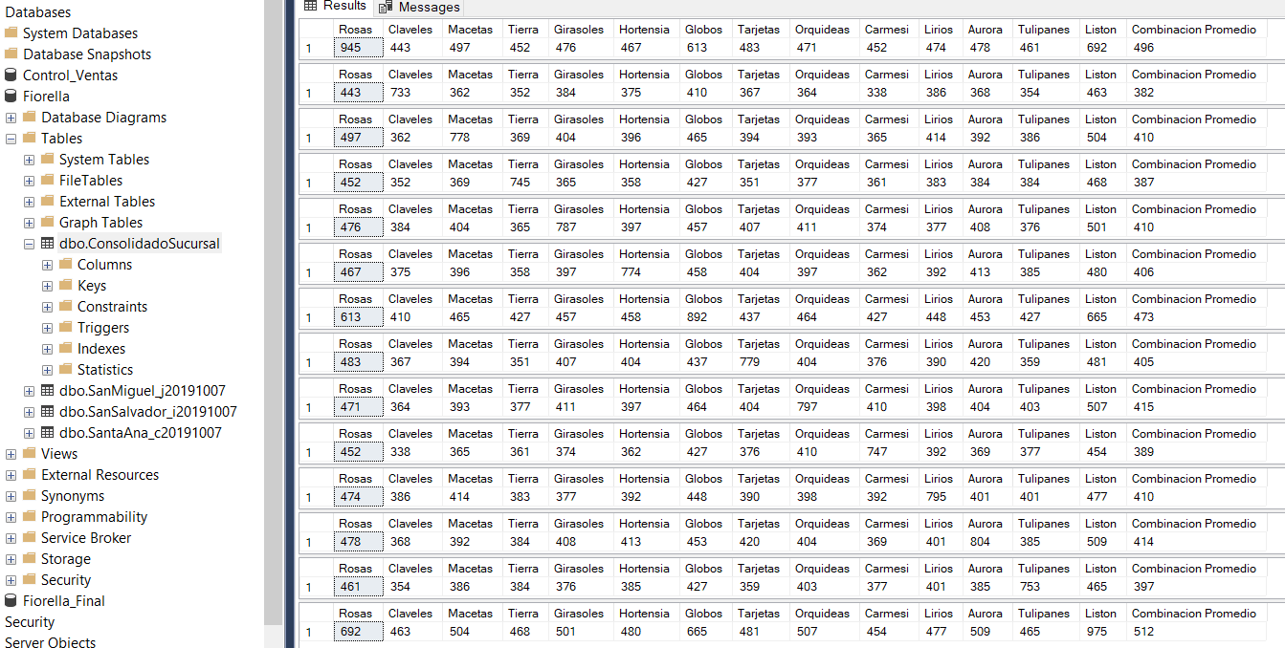

**Consultas SQL**

**San Miguel**

SELECT SUM([Rosas]) as 'Rosas', SUM([Claveles]) as 'Claveles',SUM([Macetas]) as 'Macetas',SUM([Tierra]) as 'Tierra',

SUM([Girasoles]) as 'Girasoles',SUM([Hortensia]) as 'Hortensia',SUM([Globos]) as 'Globos',SUM([Tarjetas]) as 'Tarjetas',

SUM([Orquideas]) as 'Orquideas',SUM([Carmesí]) as 'Carmesi',SUM([Lirios]) as 'Lirios',SUM([Aurora]) as 'Aurora',

SUM([Tulipanes]) as 'Tulipanes',SUM([Listón]) as 'Liston', SUM([Claveles]+[Macetas]+[Tierra]+[Girasoles]+[Hortensia]+[Globos]+[Tarjetas]+[Orquideas]+[Carmesí]

+[Lirios]+[Aurora]+[Tulipanes]+[Listón])/13 as 'Combinacion Promedio', Sucursal

FROM [Fiorella].[dbo].ConsolidadoSucursal

WHERE [Rosas] = 1 AND Sucursal = 'San Miguel'

Group BY Sucursal

SELECT SUM([Rosas]) as 'Rosas', SUM([Claveles]) as 'Claveles',SUM([Macetas]) as 'Macetas',SUM([Tierra]) as 'Tierra',

SUM([Girasoles]) as 'Girasoles',SUM([Hortensia]) as 'Hortensia',SUM([Globos]) as 'Globos',SUM([Tarjetas]) as 'Tarjetas',

SUM([Orquideas]) as 'Orquideas',SUM([Carmesí]) as 'Carmesi',SUM([Lirios]) as 'Lirios',SUM([Aurora]) as 'Aurora',

SUM([Tulipanes]) as 'Tulipanes',SUM([Listón]) as 'Liston', SUM(Rosas+[Macetas]+[Tierra]+[Girasoles]+[Hortensia]+[Globos]+[Tarjetas]+[Orquideas]+[Carmesí]

+[Lirios]+[Aurora]+[Tulipanes]+[Listón])/13 as 'Combinacion Promedio'

FROM [Fiorella].[dbo].ConsolidadoSucursal

WHERE Claveles = 1 AND Sucursal = 'San Miguel'

SELECT SUM([Rosas]) as 'Rosas', SUM([Claveles]) as 'Claveles',SUM([Macetas]) as 'Macetas',SUM([Tierra]) as 'Tierra',

SUM([Girasoles]) as 'Girasoles',SUM([Hortensia]) as 'Hortensia',SUM([Globos]) as 'Globos',SUM([Tarjetas]) as 'Tarjetas',

SUM([Orquideas]) as 'Orquideas',SUM([Carmesí]) as 'Carmesi',SUM([Lirios]) as 'Lirios',SUM([Aurora]) as 'Aurora',

SUM([Tulipanes]) as 'Tulipanes',SUM([Listón]) as 'Liston', SUM([Claveles]+rosas+[Tierra]+[Girasoles]+[Hortensia]+[Globos]+[Tarjetas]+[Orquideas]+[Carmesí]

+[Lirios]+[Aurora]+[Tulipanes]+[Listón])/13 as 'Combinacion Promedio'

FROM [Fiorella].[dbo].ConsolidadoSucursal

WHERE Macetas = 1 AND Sucursal = 'San Miguel'

SELECT SUM([Rosas]) as 'Rosas', SUM([Claveles]) as 'Claveles',SUM([Macetas]) as 'Macetas',SUM([Tierra]) as 'Tierra',

SUM([Girasoles]) as 'Girasoles',SUM([Hortensia]) as 'Hortensia',SUM([Globos]) as 'Globos',SUM([Tarjetas]) as 'Tarjetas',

SUM([Orquideas]) as 'Orquideas',SUM([Carmesí]) as 'Carmesi',SUM([Lirios]) as 'Lirios',SUM([Aurora]) as 'Aurora',

SUM([Tulipanes]) as 'Tulipanes',SUM([Listón]) as 'Liston', SUM([Claveles]+[Macetas]+rosas+[Girasoles]+[Hortensia]+[Globos]+[Tarjetas]+[Orquideas]+[Carmesí]

+[Lirios]+[Aurora]+[Tulipanes]+[Listón])/13 as 'Combinacion Promedio'

FROM [Fiorella].[dbo].ConsolidadoSucursal

WHERE Tierra = 1 AND Sucursal = 'San Miguel'

SELECT SUM([Rosas]) as 'Rosas', SUM([Claveles]) as 'Claveles',SUM([Macetas]) as 'Macetas',SUM([Tierra]) as 'Tierra',

SUM([Girasoles]) as 'Girasoles',SUM([Hortensia]) as 'Hortensia',SUM([Globos]) as 'Globos',SUM([Tarjetas]) as 'Tarjetas',

SUM([Orquideas]) as 'Orquideas',SUM([Carmesí]) as 'Carmesi',SUM([Lirios]) as 'Lirios',SUM([Aurora]) as 'Aurora',

SUM([Tulipanes]) as 'Tulipanes',SUM([Listón]) as 'Liston', SUM([Claveles]+[Macetas]+[Tierra]+Rosas+[Hortensia]+[Globos]+[Tarjetas]+[Orquideas]+[Carmesí]

+[Lirios]+[Aurora]+[Tulipanes]+[Listón])/13 as 'Combinacion Promedio'

FROM [Fiorella].[dbo].ConsolidadoSucursal

WHERE Girasoles = 1 AND Sucursal = 'San Miguel'

SELECT SUM([Rosas]) as 'Rosas', SUM([Claveles]) as 'Claveles',SUM([Macetas]) as 'Macetas',SUM([Tierra]) as 'Tierra',

SUM([Girasoles]) as 'Girasoles',SUM([Hortensia]) as 'Hortensia',SUM([Globos]) as 'Globos',SUM([Tarjetas]) as 'Tarjetas',

SUM([Orquideas]) as 'Orquideas',SUM([Carmesí]) as 'Carmesi',SUM([Lirios]) as 'Lirios',SUM([Aurora]) as 'Aurora',

SUM([Tulipanes]) as 'Tulipanes',SUM([Listón]) as 'Liston', SUM([Claveles]+[Macetas]+[Tierra]+[Girasoles]+Rosas+[Globos]+[Tarjetas]+[Orquideas]+[Carmesí]

+[Lirios]+[Aurora]+[Tulipanes]+[Listón])/13 as 'Combinacion Promedio'

FROM [Fiorella].[dbo].ConsolidadoSucursal

WHERE Hortensia = 1 AND Sucursal = 'San Miguel'

SELECT SUM([Rosas]) as 'Rosas', SUM([Claveles]) as 'Claveles',SUM([Macetas]) as 'Macetas',SUM([Tierra]) as 'Tierra',

SUM([Girasoles]) as 'Girasoles',SUM([Hortensia]) as 'Hortensia',SUM([Globos]) as 'Globos',SUM([Tarjetas]) as 'Tarjetas',

SUM([Orquideas]) as 'Orquideas',SUM([Carmesí]) as 'Carmesi',SUM([Lirios]) as 'Lirios',SUM([Aurora]) as 'Aurora',

SUM([Tulipanes]) as 'Tulipanes',SUM([Listón]) as 'Liston', SUM([Claveles]+[Macetas]+[Tierra]+[Girasoles]+[Hortensia]+Rosas+[Tarjetas]+[Orquideas]+[Carmesí]

+[Lirios]+[Aurora]+[Tulipanes]+[Listón])/13 as 'Combinacion Promedio'

FROM [Fiorella].[dbo].ConsolidadoSucursal

WHERE Globos = 1 AND Sucursal = 'San Miguel'

SELECT SUM([Rosas]) as 'Rosas', SUM([Claveles]) as 'Claveles',SUM([Macetas]) as 'Macetas',SUM([Tierra]) as 'Tierra',

SUM([Girasoles]) as 'Girasoles',SUM([Hortensia]) as 'Hortensia',SUM([Globos]) as 'Globos',SUM([Tarjetas]) as 'Tarjetas',

SUM([Orquideas]) as 'Orquideas',SUM([Carmesí]) as 'Carmesi',SUM([Lirios]) as 'Lirios',SUM([Aurora]) as 'Aurora',

SUM([Tulipanes]) as 'Tulipanes',SUM([Listón]) as 'Liston', SUM([Claveles]+[Macetas]+[Tierra]+[Girasoles]+[Hortensia]+[Globos]+Rosas+[Orquideas]+[Carmesí]

+[Lirios]+[Aurora]+[Tulipanes]+[Listón])/13 as 'Combinacion Promedio'

FROM [Fiorella].[dbo].ConsolidadoSucursal

WHERE Tarjetas = 1 AND Sucursal = 'San Miguel'

SELECT SUM([Rosas]) as 'Rosas', SUM([Claveles]) as 'Claveles',SUM([Macetas]) as 'Macetas',SUM([Tierra]) as 'Tierra',

SUM([Girasoles]) as 'Girasoles',SUM([Hortensia]) as 'Hortensia',SUM([Globos]) as 'Globos',SUM([Tarjetas]) as 'Tarjetas',

SUM([Orquideas]) as 'Orquideas',SUM([Carmesí]) as 'Carmesi',SUM([Lirios]) as 'Lirios',SUM([Aurora]) as 'Aurora',

SUM([Tulipanes]) as 'Tulipanes',SUM([Listón]) as 'Liston', SUM([Claveles]+[Macetas]+[Tierra]+[Girasoles]+[Hortensia]+[Globos]+[Tarjetas]+Rosas+[Carmesí]

+[Lirios]+[Aurora]+[Tulipanes]+[Listón])/13 as 'Combinacion Promedio'

FROM [Fiorella].[dbo].ConsolidadoSucursal

WHERE [Orquideas] = 1 AND Sucursal = 'San Miguel'

SELECT SUM([Rosas]) as 'Rosas', SUM([Claveles]) as 'Claveles',SUM([Macetas]) as 'Macetas',SUM([Tierra]) as 'Tierra',

SUM([Girasoles]) as 'Girasoles',SUM([Hortensia]) as 'Hortensia',SUM([Globos]) as 'Globos',SUM([Tarjetas]) as 'Tarjetas',

SUM([Orquideas]) as 'Orquideas',SUM([Carmesí]) as 'Carmesi',SUM([Lirios]) as 'Lirios',SUM([Aurora]) as 'Aurora',

SUM([Tulipanes]) as 'Tulipanes',SUM([Listón]) as 'Liston', SUM([Claveles]+[Macetas]+[Tierra]+[Girasoles]+[Hortensia]+[Globos]+[Tarjetas]+[Orquideas]+Rosas

+[Lirios]+[Aurora]+[Tulipanes]+[Listón])/13 as 'Combinacion Promedio'

FROM [Fiorella].[dbo].ConsolidadoSucursal

WHERE Carmesí = 1 AND Sucursal = 'San Miguel'

SELECT SUM([Rosas]) as 'Rosas', SUM([Claveles]) as 'Claveles',SUM([Macetas]) as 'Macetas',SUM([Tierra]) as 'Tierra',

SUM([Girasoles]) as 'Girasoles',SUM([Hortensia]) as 'Hortensia',SUM([Globos]) as 'Globos',SUM([Tarjetas]) as 'Tarjetas',

SUM([Orquideas]) as 'Orquideas',SUM([Carmesí]) as 'Carmesi',SUM([Lirios]) as 'Lirios',SUM([Aurora]) as 'Aurora',

SUM([Tulipanes]) as 'Tulipanes',SUM([Listón]) as 'Liston', SUM([Claveles]+[Macetas]+[Tierra]+[Girasoles]+[Hortensia]+[Globos]+[Tarjetas]+[Orquideas]+[Carmesí]

+Rosas+[Aurora]+[Tulipanes]+[Listón])/13 as 'Combinacion Promedio'

FROM [Fiorella].[dbo].ConsolidadoSucursal

WHERE Lirios = 1 AND Sucursal = 'San Miguel'

SELECT SUM([Rosas]) as 'Rosas', SUM([Claveles]) as 'Claveles',SUM([Macetas]) as 'Macetas',SUM([Tierra]) as 'Tierra',

SUM([Girasoles]) as 'Girasoles',SUM([Hortensia]) as 'Hortensia',SUM([Globos]) as 'Globos',SUM([Tarjetas]) as 'Tarjetas',

SUM([Orquideas]) as 'Orquideas',SUM([Carmesí]) as 'Carmesi',SUM([Lirios]) as 'Lirios',SUM([Aurora]) as 'Aurora',

SUM([Tulipanes]) as 'Tulipanes',SUM([Listón]) as 'Liston', SUM([Claveles]+[Macetas]+[Tierra]+[Girasoles]+[Hortensia]+[Globos]+[Tarjetas]+[Orquideas]+[Carmesí]

+[Lirios]+Rosas+[Tulipanes]+[Listón])/13 as 'Combinacion Promedio'

FROM [Fiorella].[dbo].ConsolidadoSucursal

WHERE Aurora = 1 AND Sucursal = 'San Miguel'

SELECT SUM([Rosas]) as 'Rosas', SUM([Claveles]) as 'Claveles',SUM([Macetas]) as 'Macetas',SUM([Tierra]) as 'Tierra',

SUM([Girasoles]) as 'Girasoles',SUM([Hortensia]) as 'Hortensia',SUM([Globos]) as 'Globos',SUM([Tarjetas]) as 'Tarjetas',

SUM([Orquideas]) as 'Orquideas',SUM([Carmesí]) as 'Carmesi',SUM([Lirios]) as 'Lirios',SUM([Aurora]) as 'Aurora',

SUM([Tulipanes]) as 'Tulipanes',SUM([Listón]) as 'Liston', SUM([Claveles]+[Macetas]+[Tierra]+[Girasoles]+[Hortensia]+[Globos]+[Tarjetas]+[Orquideas]+[Carmesí]

+[Lirios]+[Aurora]+Rosas+[Listón])/13 as 'Combinacion Promedio'

FROM [Fiorella].[dbo].ConsolidadoSucursal

WHERE Tulipanes = 1 AND Sucursal = 'San Miguel'

SELECT SUM([Rosas]) as 'Rosas', SUM([Claveles]) as 'Claveles',SUM([Macetas]) as 'Macetas',SUM([Tierra]) as 'Tierra',

SUM([Girasoles]) as 'Girasoles',SUM([Hortensia]) as 'Hortensia',SUM([Globos]) as 'Globos',SUM([Tarjetas]) as 'Tarjetas',

SUM([Orquideas]) as 'Orquideas',SUM([Carmesí]) as 'Carmesi',SUM([Lirios]) as 'Lirios',SUM([Aurora]) as 'Aurora',

SUM([Tulipanes]) as 'Tulipanes',SUM([Listón]) as 'Liston', SUM([Claveles]+[Macetas]+[Tierra]+[Girasoles]+[Hortensia]+[Globos]+[Tarjetas]+[Orquideas]+[Carmesí]

+[Lirios]+[Aurora]+[Tulipanes]+Rosas)/13 as 'Combinacion Promedio'

FROM [Fiorella].[dbo].ConsolidadoSucursal

WHERE Listón = 1 AND Sucursal = 'San Miguel'

**San Salvador**

SELECT SUM([Rosas]) as 'Rosas', SUM([Claveles]) as 'Claveles',SUM([Macetas]) as 'Macetas',SUM([Tierra]) as 'Tierra',

SUM([Girasoles]) as 'Girasoles',SUM([Hortensia]) as 'Hortensia',SUM([Globos]) as 'Globos',SUM([Tarjetas]) as 'Tarjetas',

SUM([Orquideas]) as 'Orquideas',SUM([Carmesí]) as 'Carmesi',SUM([Lirios]) as 'Lirios',SUM([Aurora]) as 'Aurora',

SUM([Tulipanes]) as 'Tulipanes',SUM([Listón]) as 'Liston', SUM([Claveles]+[Macetas]+[Tierra]+[Girasoles]+[Hortensia]+[Globos]+[Tarjetas]+[Orquideas]+[Carmesí]

+[Lirios]+[Aurora]+[Tulipanes]+[Listón])/13 as 'Combinacion Promedio'

FROM [Fiorella].[dbo].ConsolidadoSucursal

WHERE [Rosas] = 1 AND Sucursal = 'San Salvador'

SELECT SUM([Rosas]) as 'Rosas', SUM([Claveles]) as 'Claveles',SUM([Macetas]) as 'Macetas',SUM([Tierra]) as 'Tierra',

SUM([Girasoles]) as 'Girasoles',SUM([Hortensia]) as 'Hortensia',SUM([Globos]) as 'Globos',SUM([Tarjetas]) as 'Tarjetas',

SUM([Orquideas]) as 'Orquideas',SUM([Carmesí]) as 'Carmesi',SUM([Lirios]) as 'Lirios',SUM([Aurora]) as 'Aurora',

SUM([Tulipanes]) as 'Tulipanes',SUM([Listón]) as 'Liston', SUM(Rosas+[Macetas]+[Tierra]+[Girasoles]+[Hortensia]+[Globos]+[Tarjetas]+[Orquideas]+[Carmesí]

+[Lirios]+[Aurora]+[Tulipanes]+[Listón])/13 as 'Combinacion Promedio'

FROM [Fiorella].[dbo].ConsolidadoSucursal

WHERE Claveles = 1 AND Sucursal = 'San Salvador'

SELECT SUM([Rosas]) as 'Rosas', SUM([Claveles]) as 'Claveles',SUM([Macetas]) as 'Macetas',SUM([Tierra]) as 'Tierra',

SUM([Girasoles]) as 'Girasoles',SUM([Hortensia]) as 'Hortensia',SUM([Globos]) as 'Globos',SUM([Tarjetas]) as 'Tarjetas',

SUM([Orquideas]) as 'Orquideas',SUM([Carmesí]) as 'Carmesi',SUM([Lirios]) as 'Lirios',SUM([Aurora]) as 'Aurora',

SUM([Tulipanes]) as 'Tulipanes',SUM([Listón]) as 'Liston', SUM([Claveles]+rosas+[Tierra]+[Girasoles]+[Hortensia]+[Globos]+[Tarjetas]+[Orquideas]+[Carmesí]

+[Lirios]+[Aurora]+[Tulipanes]+[Listón])/13 as 'Combinacion Promedio'

FROM [Fiorella].[dbo].ConsolidadoSucursal

WHERE Macetas = 1 AND Sucursal = 'San Salvador'

SELECT SUM([Rosas]) as 'Rosas', SUM([Claveles]) as 'Claveles',SUM([Macetas]) as 'Macetas',SUM([Tierra]) as 'Tierra',

SUM([Girasoles]) as 'Girasoles',SUM([Hortensia]) as 'Hortensia',SUM([Globos]) as 'Globos',SUM([Tarjetas]) as 'Tarjetas',

SUM([Orquideas]) as 'Orquideas',SUM([Carmesí]) as 'Carmesi',SUM([Lirios]) as 'Lirios',SUM([Aurora]) as 'Aurora',

SUM([Tulipanes]) as 'Tulipanes',SUM([Listón]) as 'Liston', SUM([Claveles]+[Macetas]+rosas+[Girasoles]+[Hortensia]+[Globos]+[Tarjetas]+[Orquideas]+[Carmesí]

+[Lirios]+[Aurora]+[Tulipanes]+[Listón])/13 as 'Combinacion Promedio'

FROM [Fiorella].[dbo].ConsolidadoSucursal

WHERE Tierra = 1 AND Sucursal = 'San Salvador'

SELECT SUM([Rosas]) as 'Rosas', SUM([Claveles]) as 'Claveles',SUM([Macetas]) as 'Macetas',SUM([Tierra]) as 'Tierra',

SUM([Girasoles]) as 'Girasoles',SUM([Hortensia]) as 'Hortensia',SUM([Globos]) as 'Globos',SUM([Tarjetas]) as 'Tarjetas',

SUM([Orquideas]) as 'Orquideas',SUM([Carmesí]) as 'Carmesi',SUM([Lirios]) as 'Lirios',SUM([Aurora]) as 'Aurora',

SUM([Tulipanes]) as 'Tulipanes',SUM([Listón]) as 'Liston', SUM([Claveles]+[Macetas]+[Tierra]+Rosas+[Hortensia]+[Globos]+[Tarjetas]+[Orquideas]+[Carmesí]

+[Lirios]+[Aurora]+[Tulipanes]+[Listón])/13 as 'Combinacion Promedio'

FROM [Fiorella].[dbo].ConsolidadoSucursal

WHERE Girasoles = 1 AND Sucursal = 'San Salvador'

SELECT SUM([Rosas]) as 'Rosas', SUM([Claveles]) as 'Claveles',SUM([Macetas]) as 'Macetas',SUM([Tierra]) as 'Tierra',

SUM([Girasoles]) as 'Girasoles',SUM([Hortensia]) as 'Hortensia',SUM([Globos]) as 'Globos',SUM([Tarjetas]) as 'Tarjetas',

SUM([Orquideas]) as 'Orquideas',SUM([Carmesí]) as 'Carmesi',SUM([Lirios]) as 'Lirios',SUM([Aurora]) as 'Aurora',

SUM([Tulipanes]) as 'Tulipanes',SUM([Listón]) as 'Liston', SUM([Claveles]+[Macetas]+[Tierra]+[Girasoles]+Rosas+[Globos]+[Tarjetas]+[Orquideas]+[Carmesí]

+[Lirios]+[Aurora]+[Tulipanes]+[Listón])/13 as 'Combinacion Promedio'

FROM [Fiorella].[dbo].ConsolidadoSucursal

WHERE Hortensia = 1 AND Sucursal = 'San Salvador'

SELECT SUM([Rosas]) as 'Rosas', SUM([Claveles]) as 'Claveles',SUM([Macetas]) as 'Macetas',SUM([Tierra]) as 'Tierra',

SUM([Girasoles]) as 'Girasoles',SUM([Hortensia]) as 'Hortensia',SUM([Globos]) as 'Globos',SUM([Tarjetas]) as 'Tarjetas',

SUM([Orquideas]) as 'Orquideas',SUM([Carmesí]) as 'Carmesi',SUM([Lirios]) as 'Lirios',SUM([Aurora]) as 'Aurora',

SUM([Tulipanes]) as 'Tulipanes',SUM([Listón]) as 'Liston', SUM([Claveles]+[Macetas]+[Tierra]+[Girasoles]+[Hortensia]+Rosas+[Tarjetas]+[Orquideas]+[Carmesí]

+[Lirios]+[Aurora]+[Tulipanes]+[Listón])/13 as 'Combinacion Promedio'

FROM [Fiorella].[dbo].ConsolidadoSucursal

WHERE Globos = 1 AND Sucursal = 'San Salvador'

SELECT SUM([Rosas]) as 'Rosas', SUM([Claveles]) as 'Claveles',SUM([Macetas]) as 'Macetas',SUM([Tierra]) as 'Tierra',

SUM([Girasoles]) as 'Girasoles',SUM([Hortensia]) as 'Hortensia',SUM([Globos]) as 'Globos',SUM([Tarjetas]) as 'Tarjetas',

SUM([Orquideas]) as 'Orquideas',SUM([Carmesí]) as 'Carmesi',SUM([Lirios]) as 'Lirios',SUM([Aurora]) as 'Aurora',

SUM([Tulipanes]) as 'Tulipanes',SUM([Listón]) as 'Liston', SUM([Claveles]+[Macetas]+[Tierra]+[Girasoles]+[Hortensia]+[Globos]+Rosas+[Orquideas]+[Carmesí]

+[Lirios]+[Aurora]+[Tulipanes]+[Listón])/13 as 'Combinacion Promedio'

FROM [Fiorella].[dbo].ConsolidadoSucursal

WHERE Tarjetas = 1 AND Sucursal = 'San Salvador'

SELECT SUM([Rosas]) as 'Rosas', SUM([Claveles]) as 'Claveles',SUM([Macetas]) as 'Macetas',SUM([Tierra]) as 'Tierra',

SUM([Girasoles]) as 'Girasoles',SUM([Hortensia]) as 'Hortensia',SUM([Globos]) as 'Globos',SUM([Tarjetas]) as 'Tarjetas',

SUM([Orquideas]) as 'Orquideas',SUM([Carmesí]) as 'Carmesi',SUM([Lirios]) as 'Lirios',SUM([Aurora]) as 'Aurora',

SUM([Tulipanes]) as 'Tulipanes',SUM([Listón]) as 'Liston', SUM([Claveles]+[Macetas]+[Tierra]+[Girasoles]+[Hortensia]+[Globos]+[Tarjetas]+Rosas+[Carmesí]

+[Lirios]+[Aurora]+[Tulipanes]+[Listón])/13 as 'Combinacion Promedio'

FROM [Fiorella].[dbo].ConsolidadoSucursal

WHERE [Orquideas] = 1 AND Sucursal = 'San Salvador'

SELECT SUM([Rosas]) as 'Rosas', SUM([Claveles]) as 'Claveles',SUM([Macetas]) as 'Macetas',SUM([Tierra]) as 'Tierra',

SUM([Girasoles]) as 'Girasoles',SUM([Hortensia]) as 'Hortensia',SUM([Globos]) as 'Globos',SUM([Tarjetas]) as 'Tarjetas',

SUM([Orquideas]) as 'Orquideas',SUM([Carmesí]) as 'Carmesi',SUM([Lirios]) as 'Lirios',SUM([Aurora]) as 'Aurora',

SUM([Tulipanes]) as 'Tulipanes',SUM([Listón]) as 'Liston', SUM([Claveles]+[Macetas]+[Tierra]+[Girasoles]+[Hortensia]+[Globos]+[Tarjetas]+[Orquideas]+Rosas

+[Lirios]+[Aurora]+[Tulipanes]+[Listón])/13 as 'Combinacion Promedio'

FROM [Fiorella].[dbo].ConsolidadoSucursal

WHERE Carmesí = 1 AND Sucursal = 'San Salvador'

SELECT SUM([Rosas]) as 'Rosas', SUM([Claveles]) as 'Claveles',SUM([Macetas]) as 'Macetas',SUM([Tierra]) as 'Tierra',

SUM([Girasoles]) as 'Girasoles',SUM([Hortensia]) as 'Hortensia',SUM([Globos]) as 'Globos',SUM([Tarjetas]) as 'Tarjetas',

SUM([Orquideas]) as 'Orquideas',SUM([Carmesí]) as 'Carmesi',SUM([Lirios]) as 'Lirios',SUM([Aurora]) as 'Aurora',

SUM([Tulipanes]) as 'Tulipanes',SUM([Listón]) as 'Liston', SUM([Claveles]+[Macetas]+[Tierra]+[Girasoles]+[Hortensia]+[Globos]+[Tarjetas]+[Orquideas]+[Carmesí]

+Rosas+[Aurora]+[Tulipanes]+[Listón])/13 as 'Combinacion Promedio'

FROM [Fiorella].[dbo].ConsolidadoSucursal

WHERE Lirios = 1 AND Sucursal = 'San Salvador'

SELECT SUM([Rosas]) as 'Rosas', SUM([Claveles]) as 'Claveles',SUM([Macetas]) as 'Macetas',SUM([Tierra]) as 'Tierra',

SUM([Girasoles]) as 'Girasoles',SUM([Hortensia]) as 'Hortensia',SUM([Globos]) as 'Globos',SUM([Tarjetas]) as 'Tarjetas',

SUM([Orquideas]) as 'Orquideas',SUM([Carmesí]) as 'Carmesi',SUM([Lirios]) as 'Lirios',SUM([Aurora]) as 'Aurora',

SUM([Tulipanes]) as 'Tulipanes',SUM([Listón]) as 'Liston', SUM([Claveles]+[Macetas]+[Tierra]+[Girasoles]+[Hortensia]+[Globos]+[Tarjetas]+[Orquideas]+[Carmesí]

+[Lirios]+Rosas+[Tulipanes]+[Listón])/13 as 'Combinacion Promedio'

FROM [Fiorella].[dbo].ConsolidadoSucursal

WHERE Aurora = 1 AND Sucursal = 'San Salvador'

SELECT SUM([Rosas]) as 'Rosas', SUM([Claveles]) as 'Claveles',SUM([Macetas]) as 'Macetas',SUM([Tierra]) as 'Tierra',

SUM([Girasoles]) as 'Girasoles',SUM([Hortensia]) as 'Hortensia',SUM([Globos]) as 'Globos',SUM([Tarjetas]) as 'Tarjetas',

SUM([Orquideas]) as 'Orquideas',SUM([Carmesí]) as 'Carmesi',SUM([Lirios]) as 'Lirios',SUM([Aurora]) as 'Aurora',

SUM([Tulipanes]) as 'Tulipanes',SUM([Listón]) as 'Liston', SUM([Claveles]+[Macetas]+[Tierra]+[Girasoles]+[Hortensia]+[Globos]+[Tarjetas]+[Orquideas]+[Carmesí]

+[Lirios]+[Aurora]+Rosas+[Listón])/13 as 'Combinacion Promedio'

FROM [Fiorella].[dbo].ConsolidadoSucursal

WHERE Tulipanes = 1 AND Sucursal = 'San Salvador'

SELECT SUM([Rosas]) as 'Rosas', SUM([Claveles]) as 'Claveles',SUM([Macetas]) as 'Macetas',SUM([Tierra]) as 'Tierra',

SUM([Girasoles]) as 'Girasoles',SUM([Hortensia]) as 'Hortensia',SUM([Globos]) as 'Globos',SUM([Tarjetas]) as 'Tarjetas',

SUM([Orquideas]) as 'Orquideas',SUM([Carmesí]) as 'Carmesi',SUM([Lirios]) as 'Lirios',SUM([Aurora]) as 'Aurora',

SUM([Tulipanes]) as 'Tulipanes',SUM([Listón]) as 'Liston', SUM([Claveles]+[Macetas]+[Tierra]+[Girasoles]+[Hortensia]+[Globos]+[Tarjetas]+[Orquideas]+[Carmesí]

+[Lirios]+[Aurora]+[Tulipanes]+Rosas)/13 as 'Combinacion Promedio'

FROM [Fiorella].[dbo].ConsolidadoSucursal

WHERE Listón = 1 AND Sucursal = 'San Salvador'

**Santa Ana**

SELECT SUM([Rosas]) as 'Rosas', SUM([Claveles]) as 'Claveles',SUM([Macetas]) as 'Macetas',SUM([Tierra]) as 'Tierra',

SUM([Girasoles]) as 'Girasoles',SUM([Hortensia]) as 'Hortensia',SUM([Globos]) as 'Globos',SUM([Tarjetas]) as 'Tarjetas',

SUM([Orquideas]) as 'Orquideas',SUM([Carmesí]) as 'Carmesi',SUM([Lirios]) as 'Lirios',SUM([Aurora]) as 'Aurora',

SUM([Tulipanes]) as 'Tulipanes',SUM([Listón]) as 'Liston', SUM([Claveles]+[Macetas]+[Tierra]+[Girasoles]+[Hortensia]+[Globos]+[Tarjetas]+[Orquideas]+[Carmesí]

+[Lirios]+[Aurora]+[Tulipanes]+[Listón])/13 as 'Combinacion Promedio'

FROM [Fiorella].[dbo].ConsolidadoSucursal

WHERE [Rosas] = 1 AND Sucursal = 'Santa Ana'

SELECT SUM([Rosas]) as 'Rosas', SUM([Claveles]) as 'Claveles',SUM([Macetas]) as 'Macetas',SUM([Tierra]) as 'Tierra',

SUM([Girasoles]) as 'Girasoles',SUM([Hortensia]) as 'Hortensia',SUM([Globos]) as 'Globos',SUM([Tarjetas]) as 'Tarjetas',

SUM([Orquideas]) as 'Orquideas',SUM([Carmesí]) as 'Carmesi',SUM([Lirios]) as 'Lirios',SUM([Aurora]) as 'Aurora',

SUM([Tulipanes]) as 'Tulipanes',SUM([Listón]) as 'Liston', SUM(Rosas+[Macetas]+[Tierra]+[Girasoles]+[Hortensia]+[Globos]+[Tarjetas]+[Orquideas]+[Carmesí]

+[Lirios]+[Aurora]+[Tulipanes]+[Listón])/13 as 'Combinacion Promedio'

FROM [Fiorella].[dbo].ConsolidadoSucursal

WHERE Claveles = 1 AND Sucursal = 'Santa Ana'

SELECT SUM([Rosas]) as 'Rosas', SUM([Claveles]) as 'Claveles',SUM([Macetas]) as 'Macetas',SUM([Tierra]) as 'Tierra',

SUM([Girasoles]) as 'Girasoles',SUM([Hortensia]) as 'Hortensia',SUM([Globos]) as 'Globos',SUM([Tarjetas]) as 'Tarjetas',

SUM([Orquideas]) as 'Orquideas',SUM([Carmesí]) as 'Carmesi',SUM([Lirios]) as 'Lirios',SUM([Aurora]) as 'Aurora',

SUM([Tulipanes]) as 'Tulipanes',SUM([Listón]) as 'Liston', SUM([Claveles]+rosas+[Tierra]+[Girasoles]+[Hortensia]+[Globos]+[Tarjetas]+[Orquideas]+[Carmesí]

+[Lirios]+[Aurora]+[Tulipanes]+[Listón])/13 as 'Combinacion Promedio'

FROM [Fiorella].[dbo].ConsolidadoSucursal

WHERE Macetas = 1 AND Sucursal = 'Santa Ana'

SELECT SUM([Rosas]) as 'Rosas', SUM([Claveles]) as 'Claveles',SUM([Macetas]) as 'Macetas',SUM([Tierra]) as 'Tierra',

SUM([Girasoles]) as 'Girasoles',SUM([Hortensia]) as 'Hortensia',SUM([Globos]) as 'Globos',SUM([Tarjetas]) as 'Tarjetas',

SUM([Orquideas]) as 'Orquideas',SUM([Carmesí]) as 'Carmesi',SUM([Lirios]) as 'Lirios',SUM([Aurora]) as 'Aurora',

SUM([Tulipanes]) as 'Tulipanes',SUM([Listón]) as 'Liston', SUM([Claveles]+[Macetas]+rosas+[Girasoles]+[Hortensia]+[Globos]+[Tarjetas]+[Orquideas]+[Carmesí]

+[Lirios]+[Aurora]+[Tulipanes]+[Listón])/13 as 'Combinacion Promedio'

FROM [Fiorella].[dbo].ConsolidadoSucursal

WHERE Tierra = 1 AND Sucursal = 'Santa Ana'

SELECT SUM([Rosas]) as 'Rosas', SUM([Claveles]) as 'Claveles',SUM([Macetas]) as 'Macetas',SUM([Tierra]) as 'Tierra',

SUM([Girasoles]) as 'Girasoles',SUM([Hortensia]) as 'Hortensia',SUM([Globos]) as 'Globos',SUM([Tarjetas]) as 'Tarjetas',

SUM([Orquideas]) as 'Orquideas',SUM([Carmesí]) as 'Carmesi',SUM([Lirios]) as 'Lirios',SUM([Aurora]) as 'Aurora',

SUM([Tulipanes]) as 'Tulipanes',SUM([Listón]) as 'Liston', SUM([Claveles]+[Macetas]+[Tierra]+Rosas+[Hortensia]+[Globos]+[Tarjetas]+[Orquideas]+[Carmesí]

+[Lirios]+[Aurora]+[Tulipanes]+[Listón])/13 as 'Combinacion Promedio'

FROM [Fiorella].[dbo].ConsolidadoSucursal

WHERE Girasoles = 1 AND Sucursal = 'Santa Ana'

SELECT SUM([Rosas]) as 'Rosas', SUM([Claveles]) as 'Claveles',SUM([Macetas]) as 'Macetas',SUM([Tierra]) as 'Tierra',

SUM([Girasoles]) as 'Girasoles',SUM([Hortensia]) as 'Hortensia',SUM([Globos]) as 'Globos',SUM([Tarjetas]) as 'Tarjetas',

SUM([Orquideas]) as 'Orquideas',SUM([Carmesí]) as 'Carmesi',SUM([Lirios]) as 'Lirios',SUM([Aurora]) as 'Aurora',

SUM([Tulipanes]) as 'Tulipanes',SUM([Listón]) as 'Liston', SUM([Claveles]+[Macetas]+[Tierra]+[Girasoles]+Rosas+[Globos]+[Tarjetas]+[Orquideas]+[Carmesí]

+[Lirios]+[Aurora]+[Tulipanes]+[Listón])/13 as 'Combinacion Promedio'

FROM [Fiorella].[dbo].ConsolidadoSucursal

WHERE Hortensia = 1 AND Sucursal = 'Santa Ana'

SELECT SUM([Rosas]) as 'Rosas', SUM([Claveles]) as 'Claveles',SUM([Macetas]) as 'Macetas',SUM([Tierra]) as 'Tierra',

SUM([Girasoles]) as 'Girasoles',SUM([Hortensia]) as 'Hortensia',SUM([Globos]) as 'Globos',SUM([Tarjetas]) as 'Tarjetas',

SUM([Orquideas]) as 'Orquideas',SUM([Carmesí]) as 'Carmesi',SUM([Lirios]) as 'Lirios',SUM([Aurora]) as 'Aurora',

SUM([Tulipanes]) as 'Tulipanes',SUM([Listón]) as 'Liston', SUM([Claveles]+[Macetas]+[Tierra]+[Girasoles]+[Hortensia]+Rosas+[Tarjetas]+[Orquideas]+[Carmesí]

+[Lirios]+[Aurora]+[Tulipanes]+[Listón])/13 as 'Combinacion Promedio'

FROM [Fiorella].[dbo].ConsolidadoSucursal

WHERE Globos = 1 AND Sucursal = 'Santa Ana'

SELECT SUM([Rosas]) as 'Rosas', SUM([Claveles]) as 'Claveles',SUM([Macetas]) as 'Macetas',SUM([Tierra]) as 'Tierra',

SUM([Girasoles]) as 'Girasoles',SUM([Hortensia]) as 'Hortensia',SUM([Globos]) as 'Globos',SUM([Tarjetas]) as 'Tarjetas',

SUM([Orquideas]) as 'Orquideas',SUM([Carmesí]) as 'Carmesi',SUM([Lirios]) as 'Lirios',SUM([Aurora]) as 'Aurora',

SUM([Tulipanes]) as 'Tulipanes',SUM([Listón]) as 'Liston', SUM([Claveles]+[Macetas]+[Tierra]+[Girasoles]+[Hortensia]+[Globos]+Rosas+[Orquideas]+[Carmesí]

+[Lirios]+[Aurora]+[Tulipanes]+[Listón])/13 as 'Combinacion Promedio'

FROM [Fiorella].[dbo].ConsolidadoSucursal

WHERE Tarjetas = 1 AND Sucursal = 'Santa Ana'

SELECT SUM([Rosas]) as 'Rosas', SUM([Claveles]) as 'Claveles',SUM([Macetas]) as 'Macetas',SUM([Tierra]) as 'Tierra',

SUM([Girasoles]) as 'Girasoles',SUM([Hortensia]) as 'Hortensia',SUM([Globos]) as 'Globos',SUM([Tarjetas]) as 'Tarjetas',

SUM([Orquideas]) as 'Orquideas',SUM([Carmesí]) as 'Carmesi',SUM([Lirios]) as 'Lirios',SUM([Aurora]) as 'Aurora',

SUM([Tulipanes]) as 'Tulipanes',SUM([Listón]) as 'Liston', SUM([Claveles]+[Macetas]+[Tierra]+[Girasoles]+[Hortensia]+[Globos]+[Tarjetas]+Rosas+[Carmesí]

+[Lirios]+[Aurora]+[Tulipanes]+[Listón])/13 as 'Combinacion Promedio'

FROM [Fiorella].[dbo].ConsolidadoSucursal

WHERE [Orquideas] = 1 AND Sucursal = 'Santa Ana'

SELECT SUM([Rosas]) as 'Rosas', SUM([Claveles]) as 'Claveles',SUM([Macetas]) as 'Macetas',SUM([Tierra]) as 'Tierra',

SUM([Girasoles]) as 'Girasoles',SUM([Hortensia]) as 'Hortensia',SUM([Globos]) as 'Globos',SUM([Tarjetas]) as 'Tarjetas',

SUM([Orquideas]) as 'Orquideas',SUM([Carmesí]) as 'Carmesi',SUM([Lirios]) as 'Lirios',SUM([Aurora]) as 'Aurora',

SUM([Tulipanes]) as 'Tulipanes',SUM([Listón]) as 'Liston', SUM([Claveles]+[Macetas]+[Tierra]+[Girasoles]+[Hortensia]+[Globos]+[Tarjetas]+[Orquideas]+Rosas

+[Lirios]+[Aurora]+[Tulipanes]+[Listón])/13 as 'Combinacion Promedio'

FROM [Fiorella].[dbo].ConsolidadoSucursal

WHERE Carmesí = 1 AND Sucursal = 'Santa Ana'

SELECT SUM([Rosas]) as 'Rosas', SUM([Claveles]) as 'Claveles',SUM([Macetas]) as 'Macetas',SUM([Tierra]) as 'Tierra',

SUM([Girasoles]) as 'Girasoles',SUM([Hortensia]) as 'Hortensia',SUM([Globos]) as 'Globos',SUM([Tarjetas]) as 'Tarjetas',

SUM([Orquideas]) as 'Orquideas',SUM([Carmesí]) as 'Carmesi',SUM([Lirios]) as 'Lirios',SUM([Aurora]) as 'Aurora',

SUM([Tulipanes]) as 'Tulipanes',SUM([Listón]) as 'Liston', SUM([Claveles]+[Macetas]+[Tierra]+[Girasoles]+[Hortensia]+[Globos]+[Tarjetas]+[Orquideas]+[Carmesí]

+Rosas+[Aurora]+[Tulipanes]+[Listón])/13 as 'Combinacion Promedio'

FROM [Fiorella].[dbo].ConsolidadoSucursal

WHERE Lirios = 1 AND Sucursal = 'Santa Ana'

SELECT SUM([Rosas]) as 'Rosas', SUM([Claveles]) as 'Claveles',SUM([Macetas]) as 'Macetas',SUM([Tierra]) as 'Tierra',

SUM([Girasoles]) as 'Girasoles',SUM([Hortensia]) as 'Hortensia',SUM([Globos]) as 'Globos',SUM([Tarjetas]) as 'Tarjetas',

SUM([Orquideas]) as 'Orquideas',SUM([Carmesí]) as 'Carmesi',SUM([Lirios]) as 'Lirios',SUM([Aurora]) as 'Aurora',

SUM([Tulipanes]) as 'Tulipanes',SUM([Listón]) as 'Liston', SUM([Claveles]+[Macetas]+[Tierra]+[Girasoles]+[Hortensia]+[Globos]+[Tarjetas]+[Orquideas]+[Carmesí]

+[Lirios]+Rosas+[Tulipanes]+[Listón])/13 as 'Combinacion Promedio'

FROM [Fiorella].[dbo].ConsolidadoSucursal

WHERE Aurora = 1 AND Sucursal = 'Santa Ana'

SELECT SUM([Rosas]) as 'Rosas', SUM([Claveles]) as 'Claveles',SUM([Macetas]) as 'Macetas',SUM([Tierra]) as 'Tierra',

SUM([Girasoles]) as 'Girasoles',SUM([Hortensia]) as 'Hortensia',SUM([Globos]) as 'Globos',SUM([Tarjetas]) as 'Tarjetas',

SUM([Orquideas]) as 'Orquideas',SUM([Carmesí]) as 'Carmesi',SUM([Lirios]) as 'Lirios',SUM([Aurora]) as 'Aurora',

SUM([Tulipanes]) as 'Tulipanes',SUM([Listón]) as 'Liston', SUM([Claveles]+[Macetas]+[Tierra]+[Girasoles]+[Hortensia]+[Globos]+[Tarjetas]+[Orquideas]+[Carmesí]

+[Lirios]+[Aurora]+Rosas+[Listón])/13 as 'Combinacion Promedio'

FROM [Fiorella].[dbo].ConsolidadoSucursal

WHERE Tulipanes = 1 AND Sucursal = 'Santa Ana'

SELECT SUM([Rosas]) as 'Rosas', SUM([Claveles]) as 'Claveles',SUM([Macetas]) as 'Macetas',SUM([Tierra]) as 'Tierra',

SUM([Girasoles]) as 'Girasoles',SUM([Hortensia]) as 'Hortensia',SUM([Globos]) as 'Globos',SUM([Tarjetas]) as 'Tarjetas',

SUM([Orquideas]) as 'Orquideas',SUM([Carmesí]) as 'Carmesi',SUM([Lirios]) as 'Lirios',SUM([Aurora]) as 'Aurora',

SUM([Tulipanes]) as 'Tulipanes',SUM([Listón]) as 'Liston', SUM([Claveles]+[Macetas]+[Tierra]+[Girasoles]+[Hortensia]+[Globos]+[Tarjetas]+[Orquideas]+[Carmesí]

+[Lirios]+[Aurora]+[Tulipanes]+Rosas)/13 as 'Combinacion Promedio'

FROM [Fiorella].[dbo].ConsolidadoSucursal

WHERE Listón = 1 AND Sucursal = 'Santa Ana'

**Nacional**

SELECT SUM([Rosas]) as 'Rosas', SUM([Claveles]) as 'Claveles',SUM([Macetas]) as 'Macetas',SUM([Tierra]) as 'Tierra',

SUM([Girasoles]) as 'Girasoles',SUM([Hortensia]) as 'Hortensia',SUM([Globos]) as 'Globos',SUM([Tarjetas]) as 'Tarjetas',

SUM([Orquideas]) as 'Orquideas',SUM([Carmesí]) as 'Carmesi',SUM([Lirios]) as 'Lirios',SUM([Aurora]) as 'Aurora',

SUM([Tulipanes]) as 'Tulipanes',SUM([Listón]) as 'Liston', SUM([Claveles]+[Macetas]+[Tierra]+[Girasoles]+[Hortensia]+[Globos]+[Tarjetas]+[Orquideas]+[Carmesí]

+[Lirios]+[Aurora]+[Tulipanes]+[Listón])/13 as 'Combinacion Promedio'

FROM [Fiorella].[dbo].ConsolidadoSucursal

WHERE [Rosas] = 1

SELECT SUM([Rosas]) as 'Rosas', SUM([Claveles]) as 'Claveles',SUM([Macetas]) as 'Macetas',SUM([Tierra]) as 'Tierra',

SUM([Girasoles]) as 'Girasoles',SUM([Hortensia]) as 'Hortensia',SUM([Globos]) as 'Globos',SUM([Tarjetas]) as 'Tarjetas',

SUM([Orquideas]) as 'Orquideas',SUM([Carmesí]) as 'Carmesi',SUM([Lirios]) as 'Lirios',SUM([Aurora]) as 'Aurora',

SUM([Tulipanes]) as 'Tulipanes',SUM([Listón]) as 'Liston', SUM(Rosas+[Macetas]+[Tierra]+[Girasoles]+[Hortensia]+[Globos]+[Tarjetas]+[Orquideas]+[Carmesí]

+[Lirios]+[Aurora]+[Tulipanes]+[Listón])/13 as 'Combinacion Promedio'

FROM [Fiorella].[dbo].ConsolidadoSucursal

WHERE Claveles = 1

SELECT SUM([Rosas]) as 'Rosas', SUM([Claveles]) as 'Claveles',SUM([Macetas]) as 'Macetas',SUM([Tierra]) as 'Tierra',

SUM([Girasoles]) as 'Girasoles',SUM([Hortensia]) as 'Hortensia',SUM([Globos]) as 'Globos',SUM([Tarjetas]) as 'Tarjetas',

SUM([Orquideas]) as 'Orquideas',SUM([Carmesí]) as 'Carmesi',SUM([Lirios]) as 'Lirios',SUM([Aurora]) as 'Aurora',

SUM([Tulipanes]) as 'Tulipanes',SUM([Listón]) as 'Liston', SUM([Claveles]+rosas+[Tierra]+[Girasoles]+[Hortensia]+[Globos]+[Tarjetas]+[Orquideas]+[Carmesí]

+[Lirios]+[Aurora]+[Tulipanes]+[Listón])/13 as 'Combinacion Promedio'

FROM [Fiorella].[dbo].ConsolidadoSucursal

WHERE Macetas = 1

SELECT SUM([Rosas]) as 'Rosas', SUM([Claveles]) as 'Claveles',SUM([Macetas]) as 'Macetas',SUM([Tierra]) as 'Tierra',

SUM([Girasoles]) as 'Girasoles',SUM([Hortensia]) as 'Hortensia',SUM([Globos]) as 'Globos',SUM([Tarjetas]) as 'Tarjetas',

SUM([Orquideas]) as 'Orquideas',SUM([Carmesí]) as 'Carmesi',SUM([Lirios]) as 'Lirios',SUM([Aurora]) as 'Aurora',

SUM([Tulipanes]) as 'Tulipanes',SUM([Listón]) as 'Liston', SUM([Claveles]+[Macetas]+rosas+[Girasoles]+[Hortensia]+[Globos]+[Tarjetas]+[Orquideas]+[Carmesí]

+[Lirios]+[Aurora]+[Tulipanes]+[Listón])/13 as 'Combinacion Promedio'

FROM [Fiorella].[dbo].ConsolidadoSucursal

WHERE Tierra = 1

SELECT SUM([Rosas]) as 'Rosas', SUM([Claveles]) as 'Claveles',SUM([Macetas]) as 'Macetas',SUM([Tierra]) as 'Tierra',

SUM([Girasoles]) as 'Girasoles',SUM([Hortensia]) as 'Hortensia',SUM([Globos]) as 'Globos',SUM([Tarjetas]) as 'Tarjetas',

SUM([Orquideas]) as 'Orquideas',SUM([Carmesí]) as 'Carmesi',SUM([Lirios]) as 'Lirios',SUM([Aurora]) as 'Aurora',

SUM([Tulipanes]) as 'Tulipanes',SUM([Listón]) as 'Liston', SUM([Claveles]+[Macetas]+[Tierra]+Rosas+[Hortensia]+[Globos]+[Tarjetas]+[Orquideas]+[Carmesí]

+[Lirios]+[Aurora]+[Tulipanes]+[Listón])/13 as 'Combinacion Promedio'

FROM [Fiorella].[dbo].ConsolidadoSucursal

WHERE Girasoles = 1

SELECT SUM([Rosas]) as 'Rosas', SUM([Claveles]) as 'Claveles',SUM([Macetas]) as 'Macetas',SUM([Tierra]) as 'Tierra',

SUM([Girasoles]) as 'Girasoles',SUM([Hortensia]) as 'Hortensia',SUM([Globos]) as 'Globos',SUM([Tarjetas]) as 'Tarjetas',

SUM([Orquideas]) as 'Orquideas',SUM([Carmesí]) as 'Carmesi',SUM([Lirios]) as 'Lirios',SUM([Aurora]) as 'Aurora',

SUM([Tulipanes]) as 'Tulipanes',SUM([Listón]) as 'Liston', SUM([Claveles]+[Macetas]+[Tierra]+[Girasoles]+Rosas+[Globos]+[Tarjetas]+[Orquideas]+[Carmesí]

+[Lirios]+[Aurora]+[Tulipanes]+[Listón])/13 as 'Combinacion Promedio'

FROM [Fiorella].[dbo].ConsolidadoSucursal

WHERE Hortensia = 1

SELECT SUM([Rosas]) as 'Rosas', SUM([Claveles]) as 'Claveles',SUM([Macetas]) as 'Macetas',SUM([Tierra]) as 'Tierra',

SUM([Girasoles]) as 'Girasoles',SUM([Hortensia]) as 'Hortensia',SUM([Globos]) as 'Globos',SUM([Tarjetas]) as 'Tarjetas',

SUM([Orquideas]) as 'Orquideas',SUM([Carmesí]) as 'Carmesi',SUM([Lirios]) as 'Lirios',SUM([Aurora]) as 'Aurora',

SUM([Tulipanes]) as 'Tulipanes',SUM([Listón]) as 'Liston', SUM([Claveles]+[Macetas]+[Tierra]+[Girasoles]+[Hortensia]+Rosas+[Tarjetas]+[Orquideas]+[Carmesí]

+[Lirios]+[Aurora]+[Tulipanes]+[Listón])/13 as 'Combinacion Promedio'

FROM [Fiorella].[dbo].ConsolidadoSucursal

WHERE Globos = 1

SELECT SUM([Rosas]) as 'Rosas', SUM([Claveles]) as 'Claveles',SUM([Macetas]) as 'Macetas',SUM([Tierra]) as 'Tierra',

SUM([Girasoles]) as 'Girasoles',SUM([Hortensia]) as 'Hortensia',SUM([Globos]) as 'Globos',SUM([Tarjetas]) as 'Tarjetas',

SUM([Orquideas]) as 'Orquideas',SUM([Carmesí]) as 'Carmesi',SUM([Lirios]) as 'Lirios',SUM([Aurora]) as 'Aurora',

SUM([Tulipanes]) as 'Tulipanes',SUM([Listón]) as 'Liston', SUM([Claveles]+[Macetas]+[Tierra]+[Girasoles]+[Hortensia]+[Globos]+Rosas+[Orquideas]+[Carmesí]

+[Lirios]+[Aurora]+[Tulipanes]+[Listón])/13 as 'Combinacion Promedio'

FROM [Fiorella].[dbo].ConsolidadoSucursal

WHERE Tarjetas = 1

SELECT SUM([Rosas]) as 'Rosas', SUM([Claveles]) as 'Claveles',SUM([Macetas]) as 'Macetas',SUM([Tierra]) as 'Tierra',

SUM([Girasoles]) as 'Girasoles',SUM([Hortensia]) as 'Hortensia',SUM([Globos]) as 'Globos',SUM([Tarjetas]) as 'Tarjetas',

SUM([Orquideas]) as 'Orquideas',SUM([Carmesí]) as 'Carmesi',SUM([Lirios]) as 'Lirios',SUM([Aurora]) as 'Aurora',

SUM([Tulipanes]) as 'Tulipanes',SUM([Listón]) as 'Liston', SUM([Claveles]+[Macetas]+[Tierra]+[Girasoles]+[Hortensia]+[Globos]+[Tarjetas]+Rosas+[Carmesí]

+[Lirios]+[Aurora]+[Tulipanes]+[Listón])/13 as 'Combinacion Promedio'

FROM [Fiorella].[dbo].ConsolidadoSucursal

WHERE [Orquideas] = 1

SELECT SUM([Rosas]) as 'Rosas', SUM([Claveles]) as 'Claveles',SUM([Macetas]) as 'Macetas',SUM([Tierra]) as 'Tierra',

SUM([Girasoles]) as 'Girasoles',SUM([Hortensia]) as 'Hortensia',SUM([Globos]) as 'Globos',SUM([Tarjetas]) as 'Tarjetas',

SUM([Orquideas]) as 'Orquideas',SUM([Carmesí]) as 'Carmesi',SUM([Lirios]) as 'Lirios',SUM([Aurora]) as 'Aurora',

SUM([Tulipanes]) as 'Tulipanes',SUM([Listón]) as 'Liston', SUM([Claveles]+[Macetas]+[Tierra]+[Girasoles]+[Hortensia]+[Globos]+[Tarjetas]+[Orquideas]+Rosas

+[Lirios]+[Aurora]+[Tulipanes]+[Listón])/13 as 'Combinacion Promedio'

FROM [Fiorella].[dbo].ConsolidadoSucursal

WHERE Carmesí = 1

SELECT SUM([Rosas]) as 'Rosas', SUM([Claveles]) as 'Claveles',SUM([Macetas]) as 'Macetas',SUM([Tierra]) as 'Tierra',

SUM([Girasoles]) as 'Girasoles',SUM([Hortensia]) as 'Hortensia',SUM([Globos]) as 'Globos',SUM([Tarjetas]) as 'Tarjetas',

SUM([Orquideas]) as 'Orquideas',SUM([Carmesí]) as 'Carmesi',SUM([Lirios]) as 'Lirios',SUM([Aurora]) as 'Aurora',

SUM([Tulipanes]) as 'Tulipanes',SUM([Listón]) as 'Liston', SUM([Claveles]+[Macetas]+[Tierra]+[Girasoles]+[Hortensia]+[Globos]+[Tarjetas]+[Orquideas]+[Carmesí]

+Rosas+[Aurora]+[Tulipanes]+[Listón])/13 as 'Combinacion Promedio'

FROM [Fiorella].[dbo].ConsolidadoSucursal

WHERE Lirios = 1

SELECT SUM([Rosas]) as 'Rosas', SUM([Claveles]) as 'Claveles',SUM([Macetas]) as 'Macetas',SUM([Tierra]) as 'Tierra',

SUM([Girasoles]) as 'Girasoles',SUM([Hortensia]) as 'Hortensia',SUM([Globos]) as 'Globos',SUM([Tarjetas]) as 'Tarjetas',

SUM([Orquideas]) as 'Orquideas',SUM([Carmesí]) as 'Carmesi',SUM([Lirios]) as 'Lirios',SUM([Aurora]) as 'Aurora',

SUM([Tulipanes]) as 'Tulipanes',SUM([Listón]) as 'Liston', SUM([Claveles]+[Macetas]+[Tierra]+[Girasoles]+[Hortensia]+[Globos]+[Tarjetas]+[Orquideas]+[Carmesí]

+[Lirios]+Rosas+[Tulipanes]+[Listón])/13 as 'Combinacion Promedio'

FROM [Fiorella].[dbo].ConsolidadoSucursal

WHERE Aurora = 1

SELECT SUM([Rosas]) as 'Rosas', SUM([Claveles]) as 'Claveles',SUM([Macetas]) as 'Macetas',SUM([Tierra]) as 'Tierra',

SUM([Girasoles]) as 'Girasoles',SUM([Hortensia]) as 'Hortensia',SUM([Globos]) as 'Globos',SUM([Tarjetas]) as 'Tarjetas',

SUM([Orquideas]) as 'Orquideas',SUM([Carmesí]) as 'Carmesi',SUM([Lirios]) as 'Lirios',SUM([Aurora]) as 'Aurora',

SUM([Tulipanes]) as 'Tulipanes',SUM([Listón]) as 'Liston', SUM([Claveles]+[Macetas]+[Tierra]+[Girasoles]+[Hortensia]+[Globos]+[Tarjetas]+[Orquideas]+[Carmesí]

+[Lirios]+[Aurora]+Rosas+[Listón])/13 as 'Combinacion Promedio'

FROM [Fiorella].[dbo].ConsolidadoSucursal

WHERE Tulipanes = 1

SELECT SUM([Rosas]) as 'Rosas', SUM([Claveles]) as 'Claveles',SUM([Macetas]) as 'Macetas',SUM([Tierra]) as 'Tierra',

SUM([Girasoles]) as 'Girasoles',SUM([Hortensia]) as 'Hortensia',SUM([Globos]) as 'Globos',SUM([Tarjetas]) as 'Tarjetas',

SUM([Orquideas]) as 'Orquideas',SUM([Carmesí]) as 'Carmesi',SUM([Lirios]) as 'Lirios',SUM([Aurora]) as 'Aurora',

SUM([Tulipanes]) as 'Tulipanes',SUM([Listón]) as 'Liston', SUM([Claveles]+[Macetas]+[Tierra]+[Girasoles]+[Hortensia]+[Globos]+[Tarjetas]+[Orquideas]+[Carmesí]

+[Lirios]+[Aurora]+[Tulipanes]+Rosas)/13 as 'Combinacion Promedio'

FROM [Fiorella].[dbo].ConsolidadoSucursal

WHERE Listón = 1